Foods I 7045 Syllabus Mrs. Angie Burgess
Fall 2016 Room E100

email: angela.burgess@ucps.k12.nc.us Phone: 704-708-5530 ext:1983
Canvas: https://ucps.instructure.com/courses/36610/assignments/syllabus
This course is an introduction to the basic principles of nutrition, wellness, and food preparation. The focus of this course is finding your nutritional needs as an individual. Emphasis is placed on the relationship of diet to health, kitchen and meal management, food preparation and sustainability for a global society, and time and resource management. The knowledge gained by studying your nutritional needs will help student awareness in regards to personal food choices and physical activity. English language arts, mathematics, science and social studies are reinforced. Foods I is a prerequisite to Foods II Honors class.

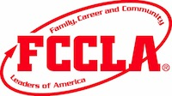Family, Career and Community Leaders of America (FCCLA) is a club that you can join by taking this class. The club is involved in competitive events, community service, and leadership activities which provide the opportunity to apply essential standards and workplace readiness skills through authentic experiences.

This class will consist of classroom discussion, note-taking, objective testing and hands-on activities in the lab. Cooking demonstrations will be a weekly feature of the course and students will have the opportunity to work cooperatively within lab groups to prepare a wide variety of different foods. Classroom participation will be an integral part of the student’s grade and everyone is expected to work with each other in a cooperative, helpful manner to make for an enjoyable group experience.

- Grading:
Tests (6 Objectives) 45%
Labs/projects 15%
Class work (in-class & take home) 15%
VOCATS (EOC) 25%
Total 100%

Tests
Tests will be given after each objective. Most objectives will have two or three standards. All questions are available on the canvas website under the heading Objective Tests. You may study ahead of time using this resource. There will also be benchmark tests after each 4 ½ weeks. The VoCATS test is a standardized test given at the end of the semester on exam days and counts 25% of your overall grade.
Labs will take place on Thursdays and Fridays if it is a regular school week. Labs on Friday will be evaluated and recorded as a lab grade. If you are absent, you are expected to make-up the lab by doing the alternate assignment. This is located on my canvas page listed above or posted on the bulletin board in my room.
Classwork/homework is assigned daily. It is expected to be completed in the time allotted for class and must be your own work. Please make sure to check my canvas page or communicate with me regarding work when you are absent.
GRADING SCALE
Grade | NUMERICAL VALUE | CP | HONORS | AP/IB/CCP/PLTW(SOME
A | 90-100 | 4 | 4.5 | 5
B | 80-89 | 3 | 3.5 | 4
C | 70-79 | 2 | 2.5 | 3
D | 60-69 | 1 | 1.5 | 2
F | 0-59 | 0 | 0 | 0

Supplies REQUIRED for class:
You will need to bring the following supplies per student:
- One/group~ Seventh Generation All Purpose Cleaner (find @ Harris Teeter & Walmart) (Mandatory). Note: this is the only cleaner allowed by the State.
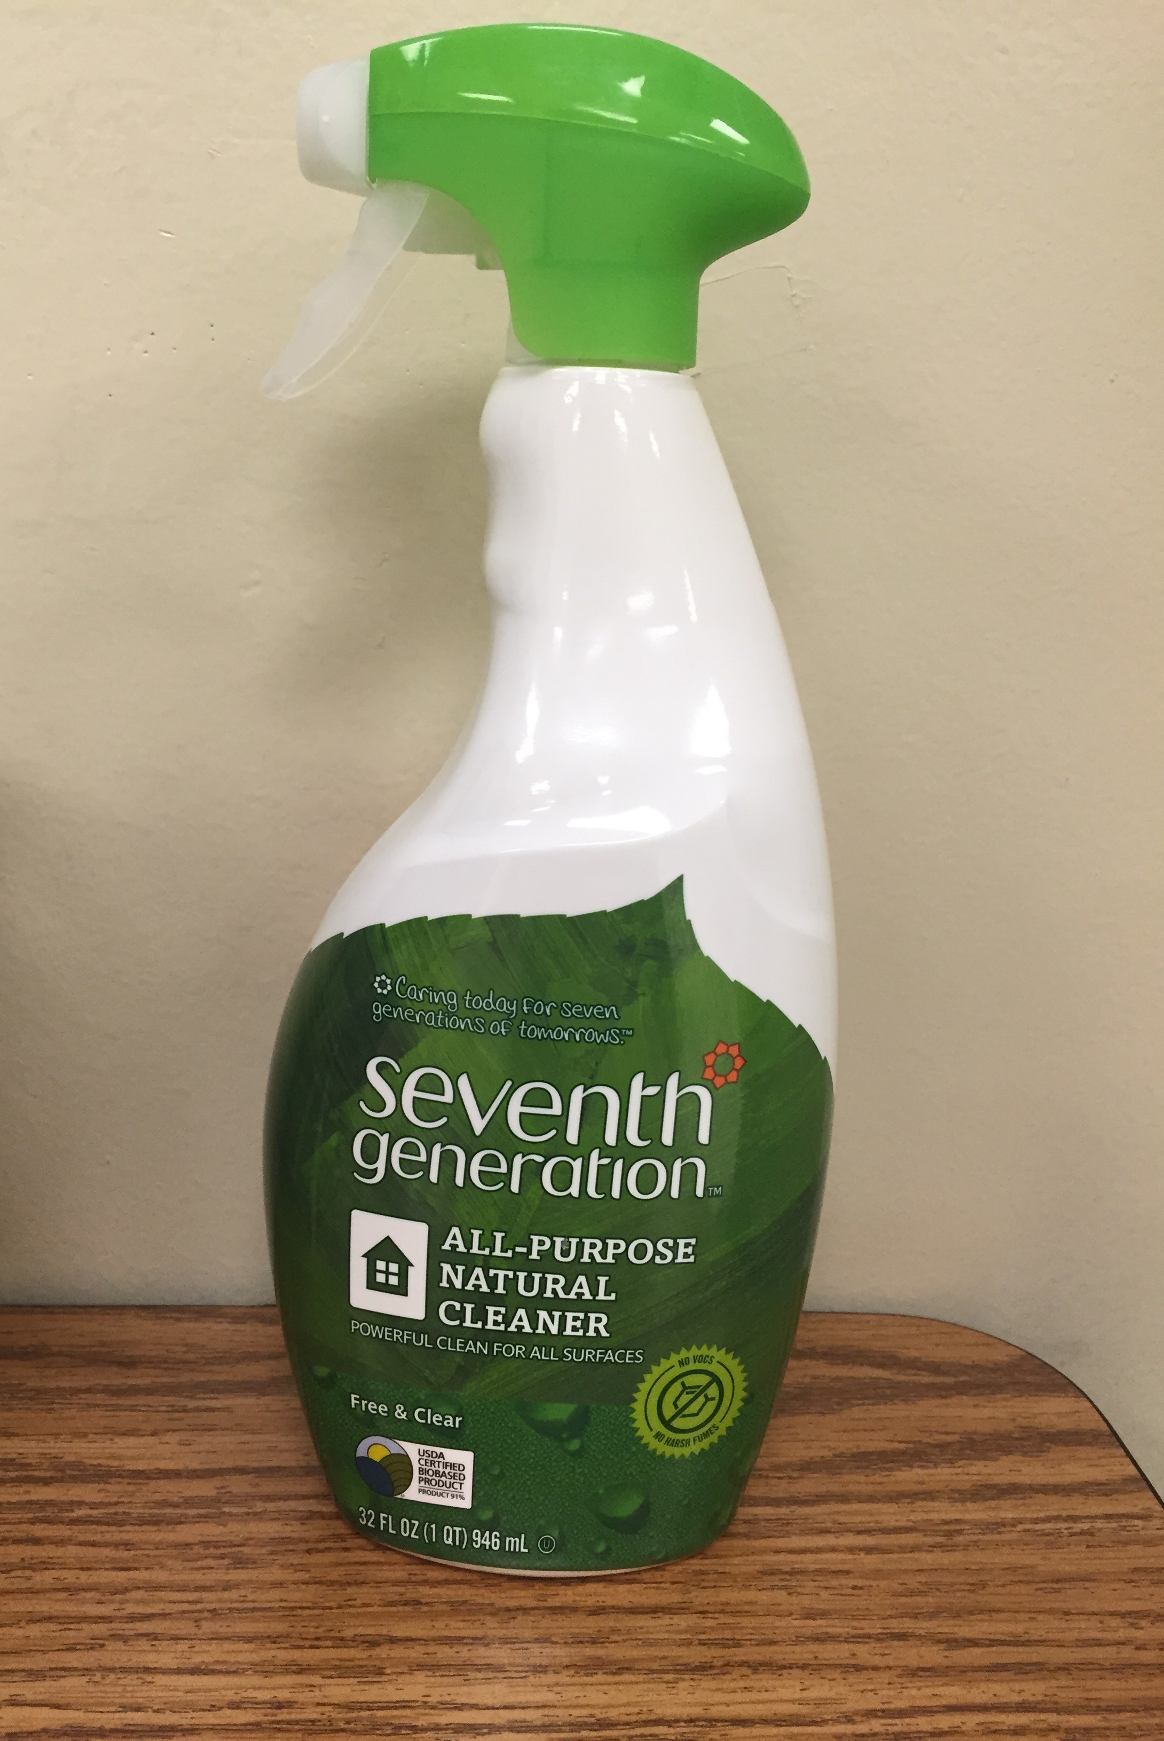
- Paper plates, cups, forks, spoons (Mandatory)-only used for your kitchen groups.
- Hair restraints (Mandatory~ this can include a baseball hat)
- Aluminum foil, saran wrap, plastic bowls to take left overs will be optional. There are many times students want to take their leftovers home. Please plan accordingly and bring needed supplies.

Course Blueprint for Foods I

 |  | Food Preparation, Processes and Methods
Objective | 1 | Understand methods for safety, sanitation, processes and conserving resources
standard | 1.01 | Understand safety and sanitation for food preparation.
 | 1.02 | Understand processes and benefits of a work plan and teamwork for preparing healthy foods.
 | 1.03 | Understand food conservation practices.
Objective | 2 | Understand methods for food preparation
Standard | 2.01 | Remember recipe parts and sources.
 | 2.02 | Remember equipment and procedures for its use and care.
 | 2.03 | Remembering measuring, cutting/preparation, mixing, and cooking/cleaning terms.
 | 2.04 | Understand how to interpret food label information and adjust recipes.
 | 2.05 | Understand procedures, equipment and cooking methods in food preparation.
 |  | Food Choices, Health, Resources, and Meal Preparation
Objective | 3 | Understand the principles of etiquette for meal service.
Standard | 3.01 | Understand the principles of basic table setting and meal service
 | 3.02 | Understand the principles of table manners.
Objective | 4 | Understand the relationship between food choices and health.
Standard | 4.01 | Understand the six nutrient groups in food.
 | 4.02 | Understand nutritional needs through the life cycle, special nutritional needs, and types of eating plans.
Objective | 5 | Understand food choices.
 | 5.01 | Understand influences on food choices.
 | 5.02 | Understand guidelines for healthful food choices.
Objective | 6 | Apply methods for meal planning and preparation.
 | 6.01 | Understand strategies of selecting and storing food.
 | 6.02 | Understand strategies in meal planning.
 | 6.03 | Apply methods to prepare healthy meals and snacks.

