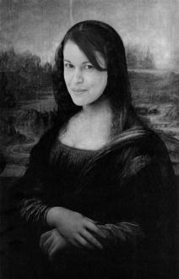
Weddington High School
Honors Art IV
Mrs. Soto – Marcellini (Room G-102)
Glory.Soto-Marcellini@ucps.k12.nc.us

Welcome back WHS Parents and Students!

Please read the information below and please sign and return the enclosed syllabus agreement.

WHS Art IV (Drawing/2-D/3-D/Photography)

Students develop, clarify, and apply their philosophy of art and art making developed in Art III through in-depth, independent, and advanced explorations with media, techniques, processes, and aesthetics. Exceptional initiative, serious involvement, and commitment are the expectations for each of the students. The course is portfolio oriented (24 pieces 2-D and 16 pieces 3-D) evidencing high quality, a broad base of knowledge, and in-depth understanding of personal art forms uniquely developed and refined. Students complete a digital portfolio of their work and an artist statement. Warning… students will experience severe “Art Nightmares”-Ms.Soto

Class Procedures: Please note that this is a combined class (Art III / Art VI). Students should be mindful and respect everyone and everything. Please do not interrupt others during instruction and art making process. All students need to be familiar with the WHS Student Handbook (see code of conduct / dress codes). Conduct violations can result in detention, parent conference, and/or referrals. This is an Honors Course and students need to be responsible for their actions, work ethics, makeup (missing) work, and need to be prepared to work from bell to bell! Please know that you are expected to work at least 10 additional hours per week on your class work.
Grading procedures

Benchmark / Final Exam: Testing will be drawn from class work discussions, vocabulary, art making techniques, and lectures. The format will consist on slide identification, essay (writing), and matching sections.
Studio Projects and Critiques: All projects will be evaluated using the 5 C’s Art rubric; Specific requirements will be used for each project based on the following criteria: Concept/ Craftsmanship / Composition/ Creativity-Originality/Challenge. Also, students will be introduced to the AP Grading rubric through the semester. The class work will consist on assigned challenging projects using a variety of styles, techniques, and media. Students will conduct individual, group, and written critiques. Some of them Formal and others Informal! Students should be respectful during such critiques and should be able to provide and accept constructive criticism.
Technology: Students will need to bring the school’s chrome books on a daily basis. An art folder will be designated with 3 components: assignment/view/edit folders. During this course, the students will create a digital portfolio using Google sites. Please be prepare to bring a digital camera (or borrow a class camera) to document art work and art in-progress (video and photographs)! Through the course, students will learn to navigate the Google Art Project Application as a tool for further research, art history, and art appreciation.
Written Assignments: There will be written assignments including: creative writing, essay writing, art reflections, research paper and art criticism (using *Feldman’s model).
*http://artistclassroom.weebly.com/feldman-approach.html)

Sketchbook: REQUIRED….see attached supplies list

Late work: Any late work will lose 10 points for each day is late. Any unfinished artwork can be completed or worked on during the student’s own time-not during the class period (you can schedule before/after school make up studio time!)
Plagiarism: Copied work will NOT be allowed in this course. It is unethical and often violates copyrights law to simply copy and image (even in another medium) that was made by someone else. Students must demonstrate originality of artwork by working during class and using sketchbook.

WHS Honor Code Policy: The Honor Code needs to be written and signed for each written assignment (research / testing/ art summary…)

“I HAVE NEITHER GIVEN NOR RECEIVED UNAUTHORIZED AID ON THIS WORK” sign Artists

Art IV Expectations:
Students are expected to be familiar with the WHS Student Code of Conduct (2014-2015) in the “Student Handbook” and be aware of all applicable consequences for conduct violations.
- Be original! Artwork copied, cliché and/or anime in style will not be graded…
- Be on time
- Be prepared
- Respect everyone and everything
- Clean up
- Make up any missing work (before/after school use of art room available upon request)
- Don’t eat / Drink / Use Cell Phone (or electronics) during class
- Don’t play with the art tools and supplies
- Offensive artwork of any kind will not be accepted. A referral and a “0” grade will be given for any type of offensive work.
- Follow the Critique Etiquette
- Be unique…creative…relax…and work hard!

Grade distribution

Course Work Grade Weighted Scale
Art Studio Projects 60% 93-100=A
Exams 10% 85-92= B
Journal/Sketchbook 20% 77-84= C
*Participation 10% 70-76 =D
0-69 =F

*Participation grades will be given daily grade based on: (1) art room clean-up, (2) art making work ethics, and (3) use of art materials.

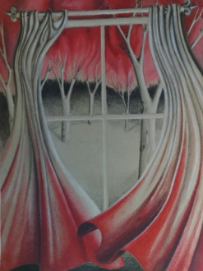
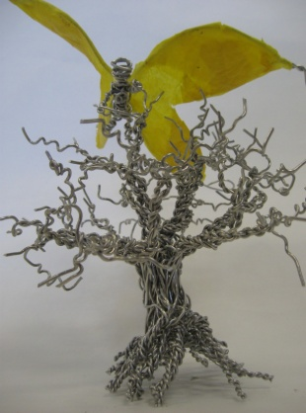
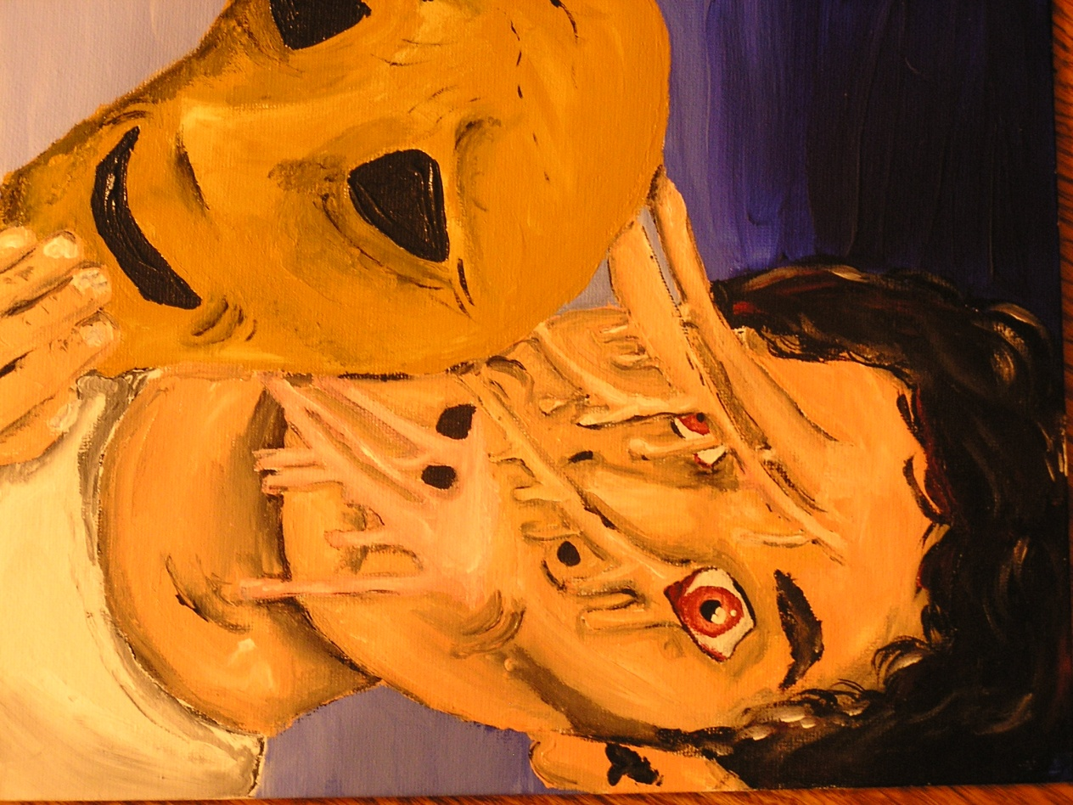

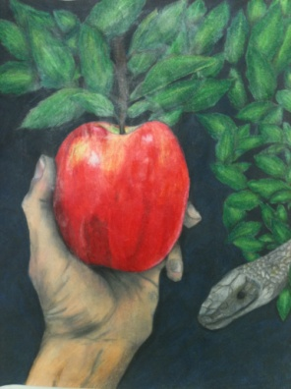
Art IV Supplies
- Sketchbook (s)…the larger the better
- Pencils / pens (for notes and test taking)/eraser/sharpies
- 2 rolls of painters blue tape
- Flash drive
- Some type of digital camera (if possible)
- Your own supplies! This is a Portfolio class and you want more than just student grade materials.
- Portfolio (to transport your artwork home!): we will work with mostly 18 x 24 size surfaces
http://mary-adam.blogspot.com/2008/08/home-made-portfolio.html
Suggested / Optional Supplies
- Surface of your choice such as: Arches / Rives BFK / Strathmore / Fabriano paper…canvas…ect
- Clay? Clay tools? Glazes?
- Media of your choice: markers, paint, spray paint…
- Tools of your choice: brushes, erasers, hole punch…
Consider your specialty (what you are good at) when purchasing supplies: drawing, painting, mixed media, printmaking, weaving, photography, 3-D…?
Materials can be found at …. Michaels, Hobby Lobby…

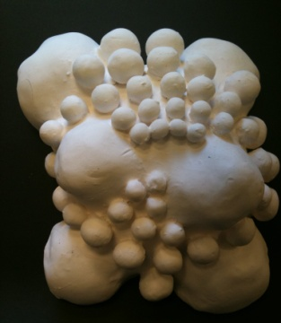
…Cheap Joe's Charlotte Store

Open 10 - 7 Mon.-Sat.
http://www.cheapjoes.com/art-stores/charlotte-nc.asp
…Binders
284 South Sharon Amity Rd
Charlotte, NC 28211
(704) 442-2608 http://www.bindersart.com/store/
…I order from: http://www.dickblick.com and http://www.saxarts.com/
Ceramics? Carolina Clay Connection

Art IV Student Name:____________________________

Please sign and return the Syllabus Agreement and the Media Use and Release Permission form to Ms. Soto…Thanks!

Dear Parent (guardian) / Student:

Please let me know if you have questions, concerns and/or suggestions! I am just an email away!

“I certify that I have read Mrs. Soto’s Honors Art IV Art Syllabus and understand the course requirements and class expectations.”

_____________________________________ _______________________________________
Parent / Guardian Sign Here Student Sign Here

Student Information (to be completed by the student)

1. Explain previous art experience(s):

2. Are you involved in any of the WHS clubs, sports, or extracurricular activities?
(…list activities)

3. Do you have access to: Computer, Printer, and/or Digital Camera at home?
Circle the one(s) that apply. Tell me about your technology proficiency, including
Programs you use…video editing…Photoshop…ect.

4. Why did you signed-up for Art IV?

