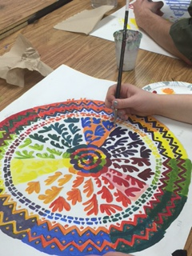
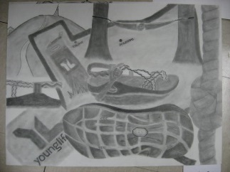
VISUAL ARTS I
Weddington High School
Mrs. Soto – Marcellini (Room G-102)
Glory.Soto-Marcellini@ucps.k12.nc.us

Course Overview

The Art I course is designed to reinforce and build on knowledge and skills developed at the elementary and middle school levels. It is the foundation level for art study throughout high school. The course is primarily devoted to create awareness and to teach various art processes, procedures, aesthetic theories, and historical developments. Students will produce two-dimensional artworks and will become art literate. The course emphasizes the study of the elements and principles of design, color theory, vocabulary, art criticism, art history, technology in art and safety in the art room. Students will develop a strong foundation in design, drawing, and vocabulary in a teacher-facilitated environment. Problem solving and decision-making are emphasized throughout Art I.

Sketchbook: A sketchbook is required for this course. A variety of sketchbook entries are due during the semester. Sketchbook = 20% of the grade

Art History: Students will research various world art periods; including artists, monuments, and specific works of art. Classwork/Participation = 10% of the class grade.
*Art criticism essays / *Google Art Project Assignments

Art Studio Projects and Critiques: Artwork will be created using a variety of media such as pencil, pastels, watercolors, color pencils, tempera, acrylics, and more! Students will be provided with specific Projects Guidelines and a Rubric. Upon completion of each project the students will complete written critiques and group critiques. Artwork is graded based on project requirements including: Concept (20%) / Craftsmanship (20%) / Creativity-Originality (20%) /Composition (20%) / Challenge (20%). Artwork = 50% of the grade

Portfolio: Students will create a digital Portfolio using Google Sites. *Artwork will be documented using a Google Site (student’s digital portfolio).

Benchmark and Final Exam: Exams will be drawn from class work discussions (vocabulary terms / art making techniques), art research/lectures, and project handouts. The format will consist on image identification, performance task, brief constructed response, extended response and selective response. All students will take 2 Benchmarks (BM) and a Final exam on this course. First BM Exams = 10% of the class grade and Second BM Exam=20% of the class grade.

WHS Honor Code Policy: Honor code needs to be written and signed for each written assignment and Google Documents (Artist Summaries /quizzes/class homework). Work without Honor Code will be given a “0”, please see student handbook for more details:
“I HAVE NEITHER GIVEN NOR RECEIVED UNAUTHORIZED AID ON THIS WORK”

Before and After School work: Students are expected to spend additional time for each Art Assignment. Work includes: written assignments, artwork, research, and vocabulary review. Please notify Ms.Soto if assistance is needed before or after school.* Artwork can only be taken home with teacher’s approval.

Artist’s Expectations:

Students are expected to be familiar with the WHS Student Code of Conduct (2016-2017) in the “Student Handbook” and be aware of all applicable consequences for conduct violations.
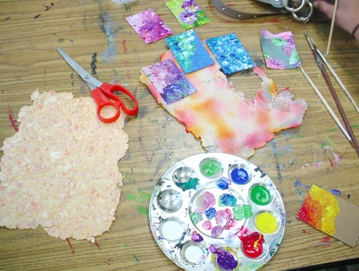
- Be on time and prepared for art…
- Respect everyone and everything
- Clean up
- Make up any missing work (before/after school use of art room available upon request)
- No Food / No Drinks (except for water) / No Use Cell Phone (or electronics) during class
- Don’t play with the art tools and supplies
- Offensive artwork of any kind will not be accepted. A referral and a “0” grade will be given for any type of offensive work.
- Don’t touch or work on other student’s artwork
- Use Critique’s Etiquette
- Be unique…creative…and work hard!

Discipline:
Please be aware of policies such as; dress code violations, disruptive conduct, tardies, classroom guidelines, use of cell phone and absences. Any school violations will result in detention and/or administration referrals (listed under the student conduct codes).

Grade Distribution

***Participation grades will be given daily and grades will be included: (1) art room clean-up, (2) art making work ethics, (3) classwork and (4) use of art materials.

Course Work Grade Weighted Scale
Art Studio Projects 50% 100-90 = A
Exams/2nd Benchmark 20% 89-80 = B
(*1st Benchmark 10%) 79-70 = C
Journal/Sketchbook 20% 69-60 = D
Participation 10% 59-0 = F

Dear Parent (guardian) / Student:

“I certify that I have read Mrs. Soto’s Art I Syllabus and understand the course requirements and class expectations.”

___________________________________ __________________________________________
Parent / Guardian Sign here Student PRINT and SIGN your name here

******Student Information (to be completed by the student)******

1. Is this your first time taking Art? If not, explain previous art experience(s):

2. Are you involved in any of the WHS/or other clubs, sports, or extracurricular activities?
(If yes…list activities)

3. Do you have access to:
Computer, Printer, and/or Digital Camera at home? * Circle the one(s) that apply

4. Why did you sign-up for Art I?

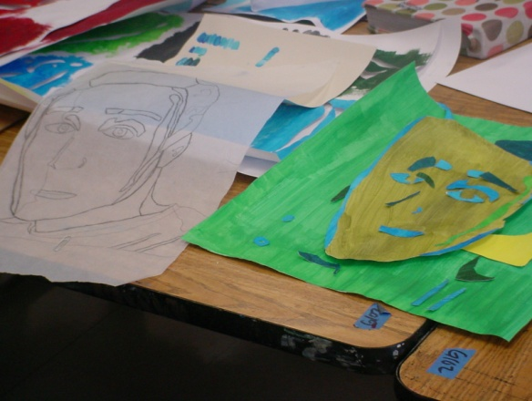
WHS - Art I Required Supplies

- Sketchbook (ring bound) – 8.5”x11”
- Pencils / Erasers / Pencil Sharpener
- Ruler (12” with numbers)
- 2 (or more!) Sharpie markers (Black - Ultra Fine)
- 2 glue sticks

DONATION IDEAS: paper plates / tissues / Lysol wipes / Black ultra fine sharpies / small paint brushes / masking tape / double sided tape / rulers / electric pencil sharpener / used hair dryers…

Suggested / Optional Supplies

- Portfolio (to transport your artwork home!): we will work with mostly 18 x 24 size surfaces
- Paper plates / yogurt cup
- ART III/IV/AP: Surface/Paper of your choice such as: Arches / Rives BFK / Strathmore / Fabriano paper…canvas…ect
- Media of your choice: markers, paint, spray paint, colored pencils…
- Tools of your choice: brushes, erasers, scissors…

Shopping for Art Materials:
Target / Michaels (look for coupons on Sunday paper!) / Hobby Lobby (find coupons online!) / A.C Moore (find coupons online!) / Wal-Mart / CVS / Walgreens / even Harris Teeter …and also:

Cheap Joe's Charlotte Store (bring student ID for discount!)
Binders (bring student ID for discount!)
Sharon Amity Rd
Charlotte, NC 28211
(704) 442-2608 http://www.bindersart.com/store/

Online Shopping? Amazon! Also try: http://www.dickblick.com and http://www.saxarts.com

