What is our review book called?

a. Why is it recommended for the AP Biology course?

b. Should you buy it right now or wait until we start review?

When are tutoring hours for A.P. Biology?

What is the date of the national AP Biology exam?

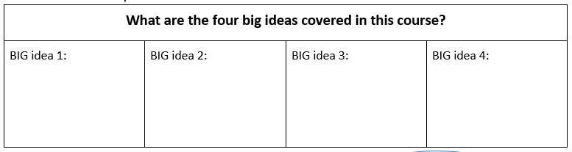

What topics will be covered in Unit 3?
How are assignments weighted in this class?

Tests: __________
Quizzes: ________
Labs: ______
Classwork/Homework: _______

How are classroom exams formatted?
Do we take late work?
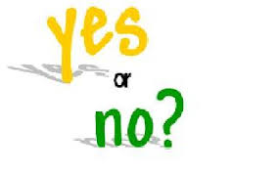
- Do we take late work?
Why?

How much of our time will be spent in the laboratory setting?
What kind of extra credit is offered?

Are reading logs optional?

What should you do if you are absent on a presentation day?
How many days do you have to make-up a reading quiz that you missed before the window closes?

What should be included in an article review?
Thing 1: | Thing 2: | Thing 3: | Thing 4:

What is the most important thing in the formula for success? __________________________________________________________________________________________________________________________________________________________________________

Syllabus Contract

I have read and fully understand the AP Biology syllabus, including but not limited to the information on p. 8-10 about grading, assignments and late work.

________________________________ ________________________ ____________
(student printed name) (student signature) (date)

________________________________ ________________________ ____________
(parent/guardian printed name) (parent/guardian signature) (date)

