TERMS OF USE:
All rights reserved by Research 2 Teacher Educational Materials.
- This product is to be used by the original purchaser only
- Intended for classroom and personal use only
- Copying for more than one teacher, classroom, department, school, or school system is prohibited
- This product may not be distributed or displayed digitally for public view
Failure to comply is a copyright infringement and a violation of the Digital Millennium Copyright Act (DMCA)

Attributions/Links for OpenStax’s Reading Guide – Chapter 8 include:

- OpenStax textbook Biology for AP ® Courses https://openstax.org/details/books/biology-ap-courses
- Scientific American https://www.scientificamerican.com/article/origin-of-oxygen-in-atmosphere/
Biello, David. “The Origin of Oxygen in Earth's Atmosphere.” Scientific American, Scientific American, 19 Aug. 2009.
- Sciencing https://sciencing.com/did-heterotrophs-evolve-autotrophs-23027.html. 18 October 2020.
Brennan, John. "Did Heterotrophs Evolve From Autotrophs?" sciencing.com.
- Khan Academy https://www.khanacademy.org/science/biology/history-of-life-on-earth/history-life-on-earth/a/hypotheses-about-the-origins-of-life
- NCBI https://www.ncbi.nlm.nih.gov/pmc/articles/PMC2964185/
Lazcano, Antonio. “Historical development of origins research.” Cold Spring Harbor perspectives in biology vol. 2,11 (2010): a002089. doi:10.1101/cshperspect.a002089
- SMBE https://doi.org/10.1093/molbev/msk014
James G. Ferry, Christopher H. House, The Stepwise Evolution of Early Life Driven by Energy Conservation, Molecular Biology and Evolution, Volume 23, Issue 6, June 2006, Pages 1286–1292
- Physics For Idiots http://physicsforidiots.com/physics/thermodynamics/
- NDT Resource Center https://www.nde-ed.org/EducationResources/CommunityCollege/RadiationSafety/introduction/gamma.htm
- Science https://science.sciencemag.org/content/360/6394/1210
- Ricochet Science https://youtu.be/13h5oC4jIsk

- Image Credits
- OpenStax https://openstax.org/details/books/biology-ap-courses
- Wikimedia Commons https://commons.wikimedia.org/wiki/File:Oxygen_atmosphere.png
- Macmillan learning, Chempendix https://sites.google.com/site/chempendix/em-spectrum
- Bioninja https://ib.bioninja.com.au/

OpenStax is a free, online textbook licensed under Creative Commons Attribution License v4.0

The OpenStax’s AP® Biology Reading Guide – Chapter 8 companion worksheet is Copyrighted © 2020 to present by Researcher 2 Teacher Educational Materials.
OpenStax’s Reading Guide – Chapter 8

Name:
Source Material
This reading guide is a companion to the free, online OpenStax textbook Biology for AP ® Courses. https://openstax.org/details/books/biology-ap-courses
Date:
Class:

Section Summaries:
Read over the summaries for each section and either (1) write a brief overview of the section’s content or (2) draw/illustrate the key terms and ideas mentioned. Summaries can be found at the OpenStax site:

https://openstax.org/books/biology-ap-courses/pages/8-introduction

8.1 Overview of Photosynthesis
The process of photosynthesis transformed life on Earth. By harnessing energy from the sun, the evolution of photosynthesis allowed living things access to enormous amounts of energy. Because of photosynthesis, living things gained access to sufficient energy that allowed them to build new structures and achieve the biodiversity evident today.
Only certain organisms, called photoautotrophs, can perform photosynthesis; they require the presence of chlorophyll, a specialized pigment that absorbs certain portions of the visible spectrum and can capture energy from sunlight. Photosynthesis uses carbon dioxide and water to assemble carbohydrate molecules and release oxygen as a waste product into the atmosphere. Eukaryotic autotrophs, such as plants and algae, have organelles called chloroplasts in which photosynthesis takes place, and starch accumulates. In prokaryotes, such as cyanobacteria, the process is less localized and occurs within folded membranes, extensions of the plasma membrane, and in the cytoplasm.

8.2 The Light-Dependent Reaction of Photosynthesis
The pigments of the first part of photosynthesis, the light-dependent reactions, absorb energy from sunlight. A photon strikes the antenna pigments of photosystem II to initiate photosynthesis. The energy travels to the reaction center that contains chlorophyll a and then to the electron transport chain, which pumps hydrogen ions into the thylakoid interior. This action builds up a high concentration of ions. The ions flow through ATP synthase via chemiosmosis to form molecules of ATP, which are used for the formation of sugar molecules in the second stage of photosynthesis. Photosystem I absorbs a second photon, which results in the formation of an NADPH molecule, another energy and reducing power carrier for the light-independent reactions.

8.3 Using Light to Make Organic Molecules
Using the energy carriers formed in the first steps of photosynthesis, the light-independent reactions, or the Calvin cycle, take in CO2 from the environment. An enzyme, RuBisCO, catalyzes a reaction with CO2 and another molecule, RuBP. After three cycles, a three-carbon molecule of G3P leaves the cycle to become part of a carbohydrate molecule. The remaining G3P molecules stay in the cycle to be regenerated into RuBP, which is then ready to react with more CO2. Photosynthesis forms an energy cycle with the process of cellular respiration. Plants need both photosynthesis and respiration for their ability to function in both the light and dark, and to be able to interconvert essential metabolites. Therefore, plants contain both chloroplasts and mitochondria.
Word Origins
Extension | Meaning | Example
meso- | middle; intermediate | mesomorph
photo- | light | photographic
-phyll | leaves; leaf structure | sporophyll
-synthesis | putting together; formation of | chemosynthesis
stoma | mouth; opening

Vocabulary:

OpenStax’s Reading Guide – Chapter 8
Use the AP Biology OpenStax Textbook, provided links and resources, and general online searches to answer the following questions.

Section 8.0 – Origins
This section is NOT in OpenStax. Use whatever resources available to you to answer the following questions.
Read about The Great Oxidation Event in this 2009 Scientific American synopsis. https://www.scientificamerican.com/article/origin-of-oxygen-in-atmosphere/
21%
- What percentage, by volume, of the Earth’s atmosphere is composed of oxygen?
- What group of organisms do scientist believe were the first photoautotrophs to evolve?
cyanobacteria; blue-green algae

- The article states that “all plants on Earth incorporate symbiotic cyanobacteria”. Explain what they mean by this? Hint: If you are unsure, google the name Lynn Margulis.
From OS 4.3 Evolution Connection: “Scientists have long noticed that bacteria, mitochondria, and chloroplasts are similar in size. We also know that bacteria have DNA and ribosomes, just as mitochondria and chloroplasts do. Scientists believe that host cells and bacteria formed an endosymbiotic relationship when the host cells ingested both aerobic and autotrophic bacteria (cyanobacteria) but did not destroy them. Through many millions of years of evolution, these ingested bacteria became more specialized in their functions, with the aerobic bacteria becoming mitochondria and the autotrophic bacteria becoming chloroplasts.” -- Endosymbiosis, Endosymbiotic Theory, or Symbiogenesis

- To the right is a chart in which three geological events are highlighted by shaded columns and letter designations and five biological events are represented by the numbered circles. Below are brief write-ups for all 8 of these events. Place the correct letter OR number next to each description.
Teacher Note: Source material at https://commons.wikimedia.org/wiki/File:Oxygen_atmosphere.png
4
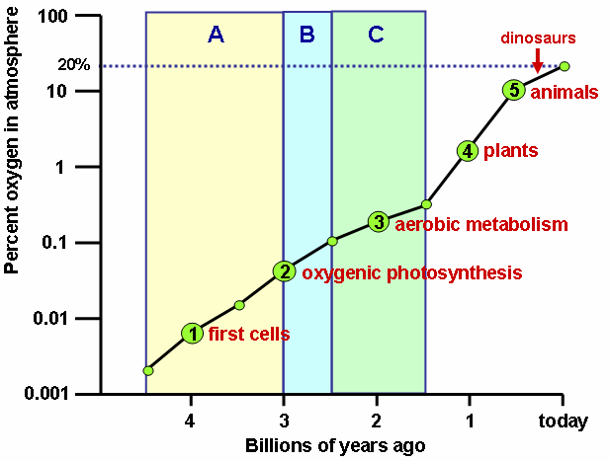
_______Evolution of multicellular plants starts
A
_______No oxidized iron found
1
_______Earliest fossilized cells found
2
_______Photosynthetic bacteria start producing O2
3
_______Aerobic metabolism evolves
C
_______Oxidized iron bands on land, ozone layer forms indicating O2 in the atmosphere
5
_______Evolution of animals starts
B
_______Oxidized iron bands in seabed rock indicate the O2 was present in the oceans
Section 8.1 – Overview of Photosynthesis
Teacher Note: The heterotroph hypothesis states that heterotrophs preceded autotrophs. https://sciencing.com/did-heterotrophs-evolve-autotrophs-23027.html
But, this theory is still very much debated with many leaning to an RNA world hypothesis:
https://www.khanacademy.org/science/biology/history-of-life-on-earth/history-life-on-earth/a/hypotheses-about-the-origins-of-life
https://www.ncbi.nlm.nih.gov/pmc/articles/PMC2964185/
https://academic.oup.com/mbe/article/23/6/1286/1055368

- Explain the differences between heterotrophs, photoautotrophs, and chemotrophs.
Because they use light to manufacture their own food, they are called photoautotrophs (literally, “self-feeders using light”). Other organisms, such as animals, fungi, and most other bacteria, are termed heterotrophs (“other feeders”), because they must rely on the sugars produced by photosynthetic organisms for their energy needs. A third very interesting group of bacteria synthesize sugars by extracting energy from inorganic chemical compounds; hence, they are referred to as chemoautotrophs.

Conventional wisdom is that the early microbes were thermophilic chemoautotrophs. These organisms seem to dominate the lower phylogenetic branches of both the Bacteria and Archaea.
- Which do you think first appeared on Earth: photoautotrophs or chemoautotrophs?
Go beyond the text…

- Fill in the missing words from these lines of text within section 8.1:
store

Photosynthesis is vital because it evolved as a way to ____________________________ the energy in
solar radiation

__________________________________ (the “photo-” part) as energy in the carbon-carbon bonds of
carbohydrate
__________________________________ molecules (the “-synthesis” part).

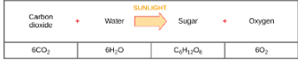
- Write-out the chemical equation for photosynthesis using both (A) words and (B) molecular formulas:
(A)
Image source: OpenStax Chapter 8

(B)
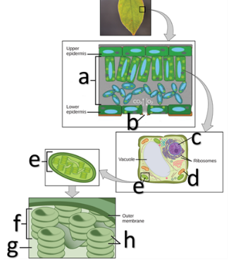
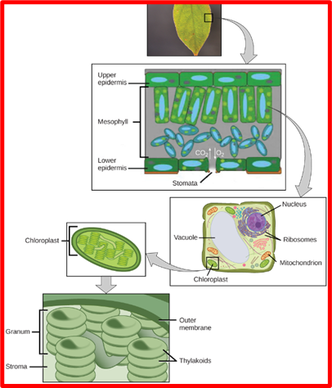
- Identify all the missing names in the following images:
Stomata
Mesophyll
Nucleus
Mitochondrion
Chloroplast
Granum

Thylakoids
Stroma

- How do guard cells regulate the stomates?
By swelling or shrinking in response to osmotic changes

- In which structure of a chloroplast is the chlorophyll located? (Circle one)
Thylakoid lumen Thylakoid membrane Stroma Inner membrane
- On a hot, dry day, plants close their stomata to conserve water. What impact will this have on photosynthesis?
(Circle one)
  - Rate of photosynthesis will be inhibited as the level of carbon dioxide decreases.
  - Rate of photosynthesis will be inhibited as the level of oxygen decreases.
  - Rate of photosynthesis will increase as the level of carbon dioxide increases.
  - Rate of photosynthesis will increase as the level of oxygen increases.

- What are the two sequential stages of photosynthesis known as?
Light-dependent and light-independent cycles (aka Calvin cycle)

- Label the two sides of this image with the appropriate stage of photosynthesis:
Teacher Note: The site listed in Q18 gives a nice overview of each law…
- Zeroth law of thermodynamics – If two thermodynamic systems are each in thermal equilibrium with a third, then they are in thermal equilibrium with each other.
- First law of thermodynamics – Energy can neither be created nor destroyed. It can only change forms. In any process, the total energy of the universe remains the same. For a thermodynamic cycle the net heat supplied to the system equals the net work done by the system.
- Second law of thermodynamics – The entropy of an isolated system not in equilibrium will tend to increase over time, approaching a maximum value at equilibrium.
- Third law of thermodynamics – As temperature approaches absolute zero, the entropy of a system approaches a constant minimum.

Light-dependent
light-independent cycles (aka Calvin cycle)
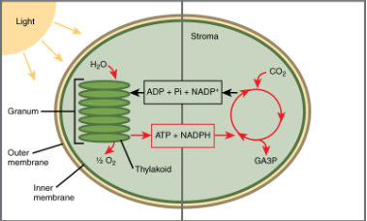
Section 8.2 The Light-Dependent Reaction of Photosynthesis
- Photosynthesis is a redox reaction. Which product is reduced, and which is oxidized?
Carbon dioxide
water
- Reduced: Oxidized:
- Electromagnetic radiation, or light, is: (Circle one) Potential Energy Kinetic Energy
- The chemical energy stored in bonds between atoms is: (Circle one) Potential Energy Kinetic Energy
- Which of the 4 laws of thermodynamics best explains how photosynthesis can transform light energy into chemical energy? HINT: check out this site for a brief tutorial on all 4 laws http://physicsforidiots.com/physics/thermodynamics/
The first law of thermodynamics; energy can neither be created nor destroyed. It can be transformed and transferred.

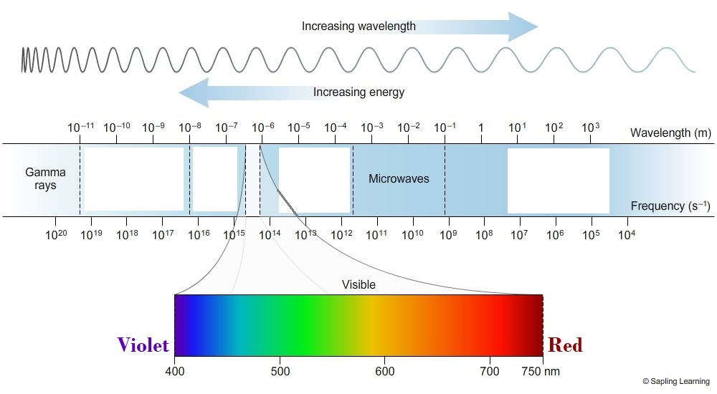
- Below is an illustration of the electromagnetic spectrum that represents the relationship between energy and wavelength. Fill in the names of the missing forms/types of radiant energy.

Radio
Infrared
UV
X-rays

Image source: https://sites.google.com/site/chempendix/em-spectrum

Bruce Banner was turned into the Hulk after being exposed to a large dose of gamma radiation that immediately mutated his DNA.
Go beyond the text…
Short, tight waves carry far more energy than longer, looser ones. Gamma radiation is the most energetic form on the spectrum and contains orders of magnitude more energy than infrared radiation
20. Speculate as to why it was so much worse for Dr. Banner to be exposed to gamma radiation then infrared radiation.

In the real world, high doses of gamma rays would fatally mutate a cell’s DNA or destroy the cell directly. In fact, Marie Curie died from illnesses caused by gamma radiation poisoning.
Source info: https://www.nde-ed.org/EducationResources/CommunityCollege/RadiationSafety/introduction/gamma.htm
21. Low doses of gamma rays are currently used in several ways. Google ‘uses of gamma radiation’ and write down one use.
Some answers include: provide information about the universe, alter semi-precious stones, industrial sensors, scan packages and vehicles, sterilization of medical equipment and foods, treat some cancers, diagnostic imaging such as a PET scan

700 nm to 400 nm
- What wavelength range (in nm) is deemed ‘photosynthetically active radiation’ for plants?

- What are the two major classes of photosynthetic pigments found in plants and algae?
chlorophylls and carotenoids

- There are only two types of chlorophyll molecules, a and b. (Circle one) TRUE FALSE
Teacher Note: The text states that there are 5 major chlorophylls. While this is true regarding ‘major’ classes, chlorophyll f was discovered in 2014 and chlorophyll e has been isolated from just two algal species (reported in 1966).
https://science.sciencemag.org/content/360/6394/1210

- Which option best identifies the function(s) of carotenoids? (Circle two)
  - They provide warning coloration to prevent the plant from being eaten by herbivores
  - They are used to attract seed dispersers
  - In photosynthesis, they act as auxiliary pigments that absorb excess energy and dissipate that energy as heat
  - In photosynthesis, they act as auxiliary pigments that repel high energy wavelengths that could damage the chlorophyll.

- What is a spectrophotometer?
An instrument that can differentiate which wavelengths of light a substance can absorb. Measure transmitted light and compute from it the absorption.

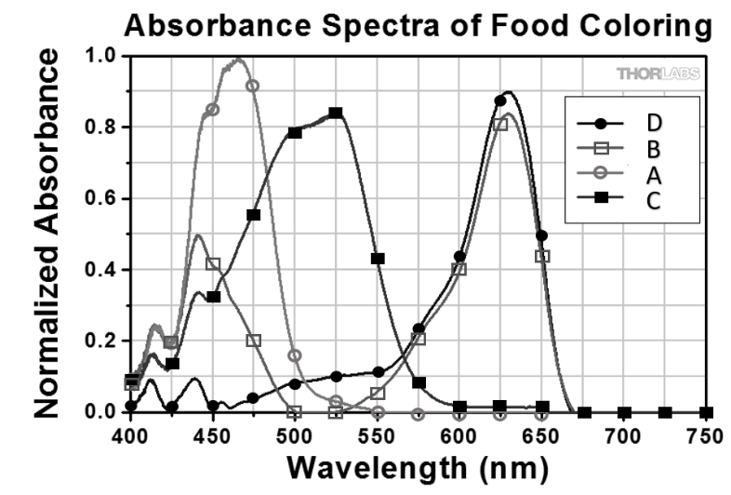
- Use the provided absorption spectrum of food colorings to answer the following questions:

  - What color of light is absorbed the most by the ‘A’ sample?
blue (460 nm)

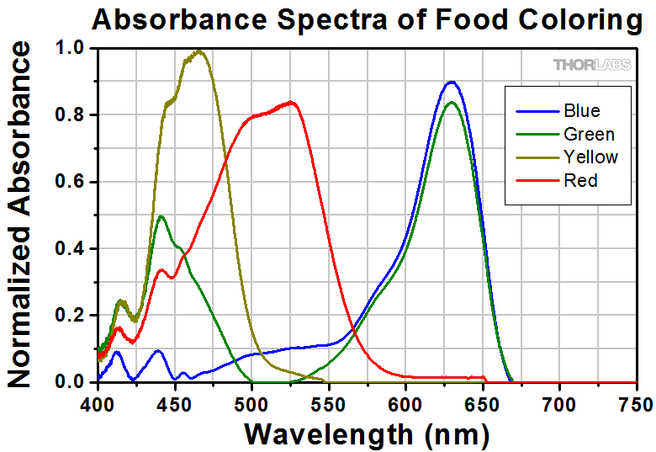
  - Which sample absorbs light between 400-500 nm and 575-680 nm?
B

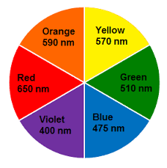
  - What color of food coloring do you think sample ‘D’ would be?
blue

  - What is the highest absorbance reading on the chart? What sample does this belong to? What colors are being absorbed?
0.99 absorbance; A; predominantly Violet & Blue (a small amount of Green)

  - What color do you expect sample ‘C’ to look like and why?
Orange/Red, it absorbs lots of green, as well as some blue and yellow, but has zero absorbance in the oranges/reds. It would reflect the orange/red back to our eyes and appear these colors.

- The overall function of light-dependent reactions is to convert solar energy into chemical energy in the form of:
NADPH
ATP
________________________ and ________________________

- While NADPH is similar to NADH, there are a few distinctions. Write the name of the correct electron carrier molecule (NADPH vs NADH) next to each statement.
NADPH
- Has one more phosphate group than the other.
NADPH
- Associated with photosynthesis.
NADH
- Mostly involved in catabolism.
NADPH
- Mostly involved in anabolism.
NADH
- Associated with cellular respiration.
- Draw in the following elements on the provided image:
  - The following labels: Thylakoid lumen, stroma, Photosystem II, Photosystem I, Electron Transport Chain, NADP⁺ reductase, ATP synthase, antenna proteins, reaction center.
  - Arrows illustrating where water is split into ½ O₂ + 2H⁺
  - Illustrate the hydrogen-ion concentration gradient and how it moves through the ATP synthase
  - Arrows illustrating the formation of ATP and NADPH
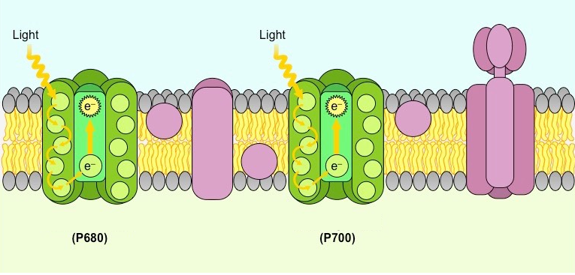
Image credit: https://ib.bioninja.com.au/
ATP
ADP + P_{i}
H⁺
H⁺
H⁺
H⁺
H⁺
H⁺
H⁺
H⁺
NADP⁺ reductase
NADPH
NADP⁺ + H⁺
Thylakoid lumen
ATP synthase
antenna proteins
reaction center
ETC
PS I
PS II
Stroma
PS II
- Which photosystem captures energy to create proton gradients to make ATP?
PS I
- Which photosystem captures energy to reduce NADP⁺ into NADPH?
- What is the external source of the electrons that ultimately pass through the photosynthetic electron transport chain?
water

Section 8.3 Using Light to Make Organic Molecules

- Where does the energy needed to run the light-independent reactions come from?
The ATP and NADPH created in the light-dependent reaction
The Calvin Cycle
- What is another name for the light-dependent reaction?
- How long can the carbohydrates made in the Calvin Cycle last?
hundreds of millions of years
in the stroma of the chloroplasts within the mesophyll cells of a leaf
- Where does the Calvin cycle take place?
- What are the three basic stages of the Calvin cycle:
fixation
reduction
regeneration

- What molecule is fixed during the first stage and what enzyme regulates the rate of this reaction?
CO₂; RuBisCO

- How many molecules of each are used in the reduction stage?
6
6
  - ATP: b. NADPH:

- What then happens to most of the ADP⁺ and NADP⁺ that are produced during this stage?
They return to the nearby light-dependent reactions to be reused and reenergized
3
- How many turns of the Calvin cycle are necessary to export one organic carbon molecule (G3P)?

Most plants are known as C3 plants because they produce a 3-carbon molecule. However, the enzyme used to fix carbon dioxide in the Calvin cycle, RuBisCO, is not very efficient and two other modes of photosynthesis, C4 and CAM, have evolved in some types of plants.

Watch
Go beyond the text…
O₂
42. What inorganic molecule did the C4 and CAM pathways evolve to avoid?
Watch this 3:30 minute video and answer the following questions: https://www.youtube.com/watch?v=13h5oC4jIsk
hot and dry
43. C4 and CAM adaptations allow plants to thrive in what type of ecological conditions?
45. CAM plants have adapted to more stressful conditions by changing what characteristic of photosynthesis?
(Circle one) Location of Calvin Cycle Timing of Calvin Cycle

44. C4 plants have adapted to more stressful conditions by changing what characteristic of photosynthesis?
(Circle one) Location of Calvin Cycle Timing of Calvin Cycle

Reflect

Use this space to write out any questions or insights you have as you work through the reading.

