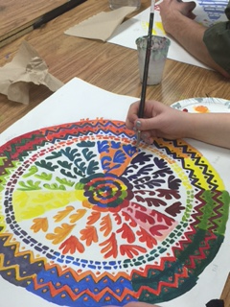
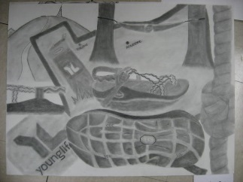
VISUAL ARTS I (Room G-102)
Weddington High School
Mrs. Soto, K-12 Art Education, MA
glory.soto-marcellini@ucps.k12.nc.us
“
“STUDENT CENTERED…FUTURE FOCUSED”

Course Overview

The Art I course is designed to reinforce and build on knowledge and skills developed at the elementary and middle school levels. It is the foundation level for art study throughout high school. The course is primarily devoted to create awareness and to teach various art processes, procedures, aesthetic theories, and historical developments. Students will produce two-dimensional artworks and will become art literate. The course emphasizes the study of the elements of art and principles of design, vocabulary, art criticism, art history, technology in art and safety in the art room. Students will develop a strong foundation in design and drawing in a teacher-facilitated environment. Problem solving and decision-making are emphasized throughout Art I while incorporating social-emotional learning.

Sketchbook: A sketchbook is required for this course. A variety of sketchbook entries are due during the semester. Sketchbook = 30% of the total grade.

Art History: Students will research various art movements; including artists, monuments, and specific works of art.
*Work includes Art Criticism Papers and Google Art Project Assignments

Art Projects and Critiques: Artwork will be created using a variety of media such as pencil, pastels, watercolors, color pencils, tempera, acrylics, and more! Students will be provided with specific Projects Guidelines and a Rubric. Upon completion of each project the students will complete individual written critiques and group critiques. Artwork is graded based on project requirements including: Concept (20%) / Craftsmanship (20%) / Creativity-Originality (20%) /Composition (20%) / Challenge (20%). Artwork = 50% of the total grade.

Portfolio: Students will create a digital Portfolio using Google Sites. *Art process and Artwork will be documented via pictures using a Google Site.

Quizzes, and Final Test: Exams will be drawn from class work discussions (vocabulary terms / art making techniques), art research/lectures, and project handouts. The format will consist on image identification, performance task, brief constructed response, extended response and selective response, the Final Test for this course is pending upon attendance (see exam exceptions on student handbook). Test/Quizzes = 20% of the grade / Final Test (if applicable) = 25% of the total grade.

WHS Honor Code Policy: Honor code needs to be written and signed for each written assignment and Google Documents as instructed (Artist Summaries /quizzes/class homework). Work without Honor Code will be given a “0”, please see student handbook for more details:
“I HAVE NEITHER GIVEN NOR RECEIVED UNAUTHORIZED AID ON THIS WORK”

Before and After School work: Students are expected to spend additional time for each Art Assignment. Work includes: written assignments, artwork, research, and vocabulary review. Please notify Ms.Soto if assistance is needed before or after school.* Artwork can only be taken home with teacher’s approval. Take advantage of the Warrior Block!

Artist’s Expectations:

Students are expected to be familiar with the WHS Student Code of Conduct (2019-2020) in the “Student Handbook” and be aware of all applicable consequences for conduct violations.
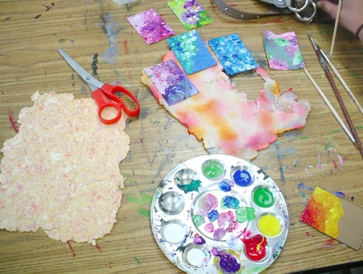
- Be on time
- Respect everyone and everything
- Clean up
- Make up any missing work (before/after school use of art room available upon request)
- No Food / No Drinks (except for water) / No Use Cell Phone (or electronics) during class
- Take care of the art tools and supplies
- Offensive artwork of any kind will not be accepted. A referral and a “0” grade will be given for any type of offensive work.
- Don’t touch or work on other student’s artwork
- Use Critique’s Etiquette
- Be unique…creative…and work hard!

Discipline:
Please be aware of policies such as; dress code violations, disruptive conduct, tardies, classroom guidelines, use of electronic (no cell phone policy) and absences. Any school violations will result in detention and/or administration referrals (listed under the student conduct codes).

Grade Distribution

***Participation grades will be given daily and grades will be included: (1) art room clean-up, (2) art making work ethics, (3) classwork and (4) use of art materials.

Course Work Grade Weighted Scale
Art Projects 50% 100-90 = A
Test/Quizzes/Benchmark 20% 89-80 = B 79-70 = C
Sketchbook 30% 69-60 = D
*classwork 59-0 = F

Dear Parent (guardian) / Student:

“I acknowledge that I have read Mrs. Soto’s Art Syllabus and understand the course requirements and class expectations.”

_______________________________________________________________________________
Parent / Guardian Print Name Preferred Contact Information

________________________________________________________________________________
Student PRINT and SIGN your name here

****************Student Information (to be completed by the student)****************

1. Is this your first time taking Art? If not, explain previous art experience(s):

2. Are you involved in any of the WHS/or other clubs, sports, or extracurricular activities?
(If yes…list activities)

3. Why did you sign-up for Art I? What would you hope to learn in Art?

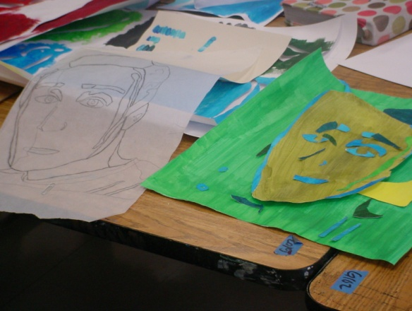
WHS - Art Required Supplies

- Sketchbook (ring bound) – 8.5”x11”
- Pencils / Erasers / Pencil Sharpener
- Ruler (12” with numbers)
- 2 (or more!) Sharpie markers (Black - Ultra Fine)
- glue stick

Supplies WISH LIST: paper plates / tissues / glue sticks / Black ultra-fine and fine sharpies / erasers/ masking tape/ painter’s tape / double sided tape / rulers / electric pencil sharpener / used hair dryers / scissors

ART III/IV/AP Suggested Supplies

- Portfolio (to transport your artwork home!): we will work with mostly 18 x 24 size surface
- Surface/Paper of your choice such as: Arches / Rives BFK / Strathmore / Fabriano paper…canvas…ect
- Media of your choice: markers, paint, spray paint, colored pencils…
- Tools of your choice: brushes, erasers, scissors…

Shopping for Art Materials:
Target / Michaels (look for coupons on Sunday paper!) / Hobby Lobby (find coupons online!) / A.C Moore (find coupons online!) / Wal-Mart / CVS / Walgreens / even Harris Teeter …and also:

Cheap Joe's Charlotte Store (bring student ID for discount!)

Online Shopping? Amazon! Also try: http://www.dickblick.com and http://www.saxarts.com

