Classroom Expectations (In-person & Virtual)
Cell Phones
Cell phones will not be tolerated in the classroom. Students will be asked to keep their phones in their book bags during class. If they cannot follow this rule, I will collect phones at the beginning of class and return them at the end. Students who do not follow this procedure, will lose participation points.
Students who are attending virtually should not use their cell phones during class. If I see them doing so, they will lose participation points.

Google Translate
Google Translate or any other online translating device is considered cheating. I expect you to use your notes to complete any assignment (or Word Reference, see below).
It is obvious when a student uses a translating device. These devices will often use grammar/vocabulary that is not specific to our lesson and is above their level. Since most of the work will be done from home and I cannot closely monitor students, I will give the students one opportunity to fix the assignment. If they continue to use this device, they will automatically receive a zero.

Word Reference
If you want to use a new vocabulary word/phrase that we have not gone over in class, you may use Word Reference. It is an online dictionary but it also includes idiomatic phrases. You will need to set your language preferences to French-English. It is NOT a translator so you can only look up single words. Make sure you pick the appropriate form of speech (vi = verb, n = noun) and the appropriate translation.

Accents on Chromebooks
Whenever you complete assignments online (homework, presentations, etc.) you are expected to include accents when necessary. You will lose points on the assignments for not having accents.
- How to include accents on Google Slides/Doc/etc.:
  - Insert Special Characters Latin find the appropriate letter with accent!
- You can also change your keyboard
  - https://www.dummies.com/computers/pcs/chromebook-change-your-keyboard-language/

Extra Credit
- No Extra Credit assignments are assigned in French Class – SO DON’T ASK!
- Some quizzes/tests include bonus questions
- Students can make up missing assignments by completing an alternate assignment for a late grade (only applicable for homework grades – THIS NEEDS TO BE DONE A WEEK PRIOR TO THE END OF THE GRADING PERIOD & MUST ASK IN ADVANCE)

Absent work
If you are absent from class (in-person or virtually), you will need to watch the video from that day’s lesson. You will also need to complete the assignments from that day’s lesson and turn in homework that was due.

Late work
- Late homework/classwork receive an automatic grade of 50%
- Late projects will lose 5 points for every day late

Live Video Lessons (Microsoft Teams)
- All students are expected to watch the live lessons during their “off-days”.
- Students should be logged in to the video stream by the time class starts (see Bell Schedule).
  - Link can be found on Canvas under “Today’s Lesson” image
- Students are expected to be engaged in the lesson.
  - They can ask/answer questions.
  - I will keep them engaged by asking them questions too (not just the “in-person” students).
  - They will be given the opportunity to interact with each other while virtual.
- Students must stayed logged in until they are dismissed.
  - Some days they will be dismissed early to complete online work, other days they will be required to stay for the entirely of the class period.

Virtual Etiquette
While virtual, students are expected to follow general “virtual etiquette guidelines”…
- Cameras on, microphones muted – unless they are asked to speak
- Find a quiet place to work away from distractions
- No distracting backgrounds – they may choose a “fun background” but it must remain the same throughout the lesson
- Be prepared with your notes/homework/notebook/etc.
- If you have a question, type your name & question into the “chat box”, do not yell it out in the middle of a lesson

Printing
You will be responsible for printing off your papers. If you do not have access to a printer, please let me know and we can make arrangements.
- You MUST print off vocabulary and grammar notes and HAND WRITE those notes.
  - I will include a “What to Print” list for each module.
- Your work will be turned in digitally so you are not required to print off those documents (see below).

How to Turn in Assignments
All assignments will be turned in via Canvas (unless otherwise noted) under the Assignments Tab.
- If it is a written assignment, you may…
  - Print off the document, hand write your answers then scan/e-mail it you yourself then upload it to Canvas
  - Make a copy of the assignment in your Google Drive (or in Word), type in your answers, upload the assignment to Canvas
- If you are asked to make a recording, you may…
  - Use your cell phone and create a voice memo then upload to Canvas
  - Use a recording website such as online-voice-recorder then upload to Canvas

Due Dates
All assignments will include a due date. Homework will typically be due the next day. ALL students will submit the homework on Canvas.

Students will be given more time for projects/presentations/tests/quizzes and those due dates will be noted on the assignment.

Tests/Quizzes
We will use various methods for tests and quizzes this year. Prior to a test/quiz, I will announce what method we will be using for that specific assessment.
- Short quiz/test during your specific “in-person” day
- Quizzes on Canvas
- At-home tests/quizzes (hand written)

Honor Code
For all assignments that are done at home, you are still on the Honor Code. As stated above, you may never use Google Translate. You must do your own work. If I receive two identical assignments, both students will receive zeroes (unless it is a partner activity).

If I suspect that a student has cheated, I will contact that student and have them re-submit it.

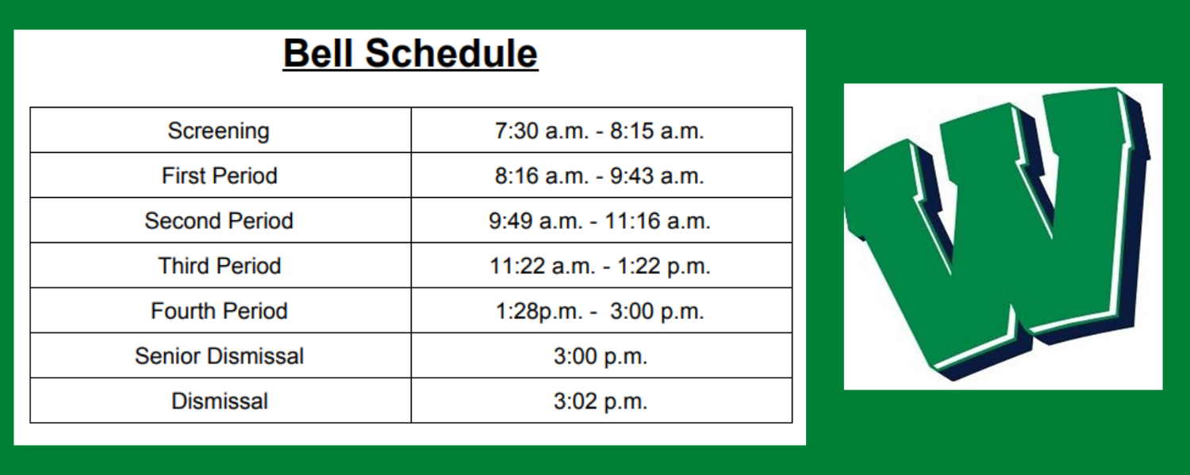
Participation Points
This semester you will receive a participation grade at the end of each six weeks. Each day you will have the opportunity to earn points and your total points at the end of the six weeks will be your grade (ie if you earned 85 points, your grade will be an 85% - test grade). The goal is to improve your speaking skills and be more comfortable speaking in French during class.

On Fridays, I will show you how many points you currently have. If you want to know your total at a different time, you may ask the following: J’ai combien de points ?

How to receive points
- volunteering to answer a question in class, read in class, present partner conversation, etc.
- asking a RELEVANT, THOUGHFUL question in class, en français bien sûr
- winning review games – QuizletLive, Kahoot, etc.
- being on task
- speaking in French during group work
- other announced opportunities trivia questions on Canvas, etc.
*Yes, you may do all of these things virtually too!*

How you lose points
- having your cell phone out (applies to virtual students too)
- being off task
- working on work for other classes or working ahead in Canvas
- having your computer out when it shouldn’t be out
- playing games on your computer instead of reviewing Quizlet (when instructed to have computer out)
*Yes, you can still lose points from at home too!*

**If you earn 3 points every day, you will have 90 points at the end of each six weeks (90%).

Signatures – by signing, you are agreeing to the classroom expectations stated above. If you have any questions or concerns, please e-mail me at: brooke.souther@ucps.k12.nc.us

A note to the parents…This is going to be a challenging year and I know that various issues will arise (wifi not working, video not uploading properly, etc.). I will be understanding of these situations and I ask that you extend the same understanding to me. I also ask that you help me out by making sure your student is logged in to the virtual lesson on time each day, that they are keep up with their work and that they are doing their OWN work. I am looking forward to a great semester together!

Parent Signature: __________________________ Parent E-mail: _________________________________

Student Signature: _____________________________________________________________________

*Please detach this page and turn it in next week*

