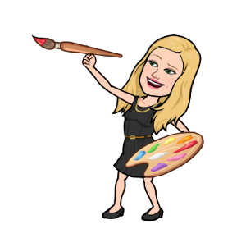K. Durbin-8th Grade Year Long Art Roster 2021-22
Saida Areh
Ella Barclay
Reuben Bonsra Jr.
Madelyn Bryant
Kaycee Chen
Rebecca Clary
Olivia Collison
Camila Cortez-Zuniga
Keira Cotter
Kiersten Davis
Zhuo Dong
Sophia Dzombar
Elizabeth Endres
Mackenzie Gainer
Cadence Guild
Katherine Harris
Amelia Holland
Emily Holliday
Maryn Iversen
Ryan Ladimir
Penelope Maddalone
Mya McCord
Cindy Nguyen
Ashley Porta
Tyler Rice
Ayelen Rodriguez
Skye Rossi
Braelynn Saunders
Sara Strawderman
Taylor Wenger
Jacob Wheelock

