SPRING BREAK 2022 IB TRIP –
OPTION 1: GREECE –
link to trip details - https://www.eftours.com/my-quotes/2394799uz/quote/2682915/47daa8d51cde4423bb
Are you ready for an adventure? We are going to explore Greece OR Peru with EF Tours in April 2022 during Spring Break. I have listed both itineraries below, and we will vote on the final destination.
EF tours are a really good value and beat out all of their competitors. They have the best itinerary and the best value for the money. I am very excited to visit Athens to see the Temple of Zeus. We will visit Delphi the Temple of Apollo, the Temple of Poseidon and see the 1896 Olympic Stadium. Most meals are included except a few lunches will be on your own. The only other expenses are travel insurance (highly recommended), Tip money for the Tour Director, Local Guides, and Bus Driver and the optional excursions.
I have included a detailed itinerary for you and one for you to share with a friend or family member. Don’t miss out on this amazing adventure! As always, email me with questions or concerns.
I can’t wait for you to join us on our “Greek Tour!”
αντιο σας (That’s “goodbye” in Greek)
Opa!
Mrs. May
TRIP INCLUDES:
- Round-trip airfare
- 9 overnight stays in hotels with private bathrooms
- Breakfast daily
- Dinner daily
- Lunch included on extension only
- Full-time services of a professional Tour Director
- Visits to select attractions as per itinerary
- Tour Diary™
- Note: On arrival day only dinner is provided; on departure day, only breakfast is provided
- Note: Tour cost does not include airline-imposed baggage fees, or fees for any required passport or visa. Please visit our Fees FAQ page for a full list of items that may not be included in the cost of your tour.
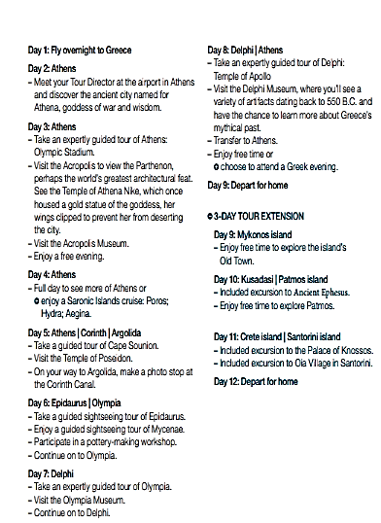

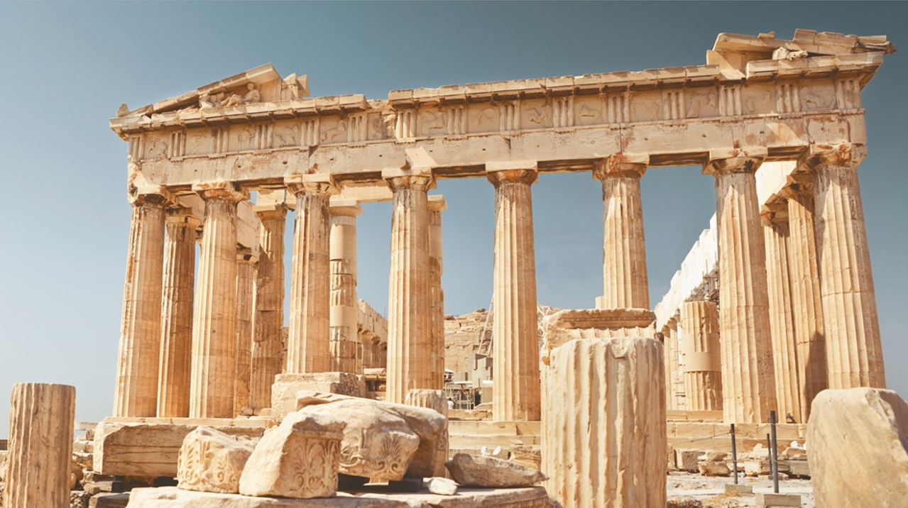
Athens, Corinth, Argolida, Epidaurus, Mycenae, Olympia, Delphi

OPTION 2:PERU –
Peru Itinerary - link to trip details

From the shores of the Pacific Ocean to the banks of Lake Titicaca in Puno, immerse yourself in the natural splendor and rich history of Peru.
This land has been home to some of the world’s most ancient civilizations. You’ll retrace the roots of the Inca Empire in Cuzco and at Machu Picchu, a destination like no other on Earth, while also exploring the Spanish Empire’s reign in Lima.
Tour Info
REQUESTED TRAVEL DATES
April 16, 2022 – April 24, 2022
YOUR ITINERARY (9 DAYS)
Day 1: Fly to Peru
– Meet your Tour Director at the airport in
Lima. Built on a coastal oasis at the foot of
the Andes, Lima has served as Peru’s capital
since 1535. See vestiges of the city’s rich
colonial heritage, including the Government
Palace, the Cathedral and the 17th-century
San Francisco monastery. Prior to the Spanish
conquest, the area was home to several Indian
civilizations. You’ll get a taste of contemporary
Lima in the suburbs of San Isidro and
Miraflores, which overlook the Pacific Ocean.
At the Larco Museum, located in an 18thcentury mansion built over a 7th-century preColumbian pyramid, you’ll find the finest gold
and silver collection from Ancient Peru, along
with other outstanding examples of art and
archaeological artifacts.
Day 2: Lima
– Take an expertly guided tour of Lima:
Government Palace; Archbishop’s Palace;
City Hall; Lima Cathedral.
– Visit the San Francisco Monastery.
– Visit the Larco Museum.
– Take a walking tour of Miraflores.
Day 3: Lima | Cuzco
– Fly to Cuzco, the “navel of the Earth” and the
former epicenter of a vast empire stretching
from Colombia to Chile. Once you’ve adjusted
to the altitude, journey to the exquisitely
preserved canals and narrow streets of
Ollantaytambo.
– Take an expertly guided tour of Ollantaytambo.
Day 4: Sacred Valley | Machu Picchu
– Travel by train to Machu Picchu.
– Visit Machu Picchu, the fabled “Lost City of the
Inca” and one of the New Seven Wonders of
the World. A 35-mile-long trail winds through
desert, cloud forest and an orchid-filled jungle
before reaching this UNESCO World Heritage
Site. Archaeologists have yet to determine why
the site, perched atop a mist-shrouded peak,
was abandoned. See remnants of temples
and terraces that have yet to reveal the true
purpose of Machu Picchu—some believe only
an elite Incan priesthood knew of its former
existence. Your visit will consist of both a
guided tour and free time to explore on
your own.
– Return by train to Sacred Valley.
Day 5: Sacred Valley | Pisac | Cuzco
– Travel to Cuzco by way of Pisac.
– Free time to explore the Indian market in Pisac.
– Take an expertly guided tour of Cuzco:
Korikancha Temple; Cuzco Cathedral.
– Visit the Sacsayhuaman Fortress.
Day 6: Raqhi | Puno
– Visit Raqhi Temple.
– Travel to Puno.
Day 7: Puno
– Enjoy a boat ride on Lake Titicaca.
– Visit Taquile and Uros Islands.
– Enjoy hiking and visiting native communities.
Day 8: Lima | Depart for home
– Travel to Juliaca.
– Fly to Lima, then depart for home.
Day 9: Arrive home
2-DAY TOUR EXTENSION
Day 8: Travel to Paracas
Day 9: Paracas
– Visit the Paracas Interpretation Center.
– Visit Paracas National Park.
– Take a walk through the desert to the
Morón Oasis.
Day 10: Lima | Depart for home
– Enjoy an Islas Ballestas boat cruise.
– Transfer to Lima, and board an overnight
flight for home.
Day 11: Arrive home

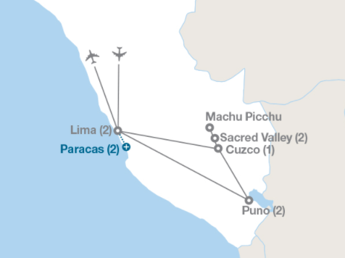

EVERYTHING YOU GET: eftours.com/
Full-time Tour Director Sightseeing:
4 sightseeing tours led by expert, licensed local guides;
1 walking tour Entrances: San Francisco Monastery; Larco Museum; Korikancha Temple; Cuzco Cathedral; Sacsayhuaman Fortress; Machu Picchu; Ollantaytambo; Raqhi Temple; Boat excursion Lake Titicaca;
With extension: Islas Ballestas boat cruise; Paracas National Park
Our personalized learning experience engages students before, during, and after tour, with the option to create a final, reflective project for academic credit All of the details are covered: Round-trip flights on major carriers; internal flight; comfortable motorcoach;
7 overnight stays in hotels (9 with extension); breakfast and dinner daily

Peru - www.eftours.com/239479
Greece - https://www.eftours.com/my-quotes/2394799uz/quote/2682915/47daa8d51cde4423bb

