Physical Science Syllabus

Course Overview
Teacher Information
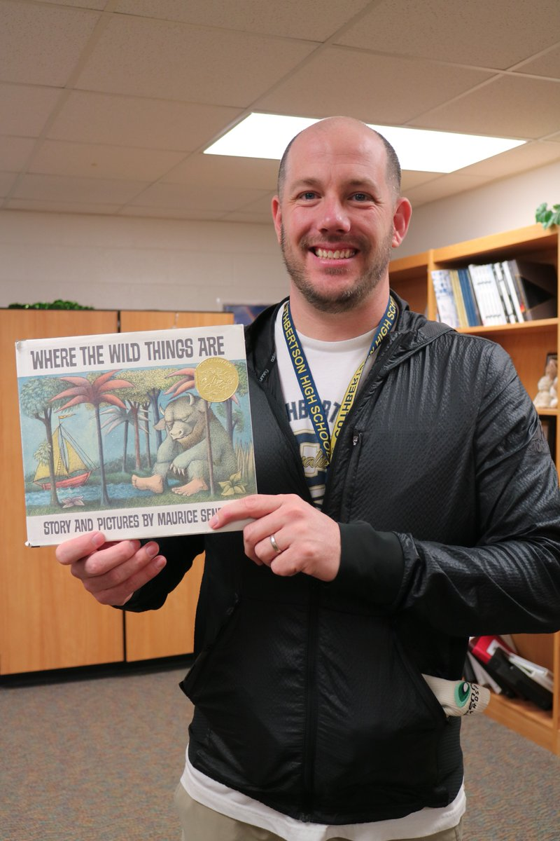

Education:  BA Geography UNCW  MAT Secondary Science UNCC | Contact Information  Email: george.beyer@ucps.k12.nc  Office Hours: Friday 7:30 to 11:30

Course Overview and Requirements
Prerequisites: Completed or taking Algebra I
Required Text: Glencoe Science Physical Science (linked on Canvas)

Course Description: The state objectives as published by the NC Department of Public Instruction are available at
http://www.dpi.state.nc.us/curriculum/science/scos/2004/
In general, the areas we will cover this year include:
Scientific Measurement
Motion: speed, velocity, acceleration,
Atomic Structure
Forces, work and power
The Periodic Law
Friction and Air resistance
Chemical Reactions
Projectile Motion
States of Matter
Simple Machines
Arrangement of Electrons
Waves
Chemical Names and Formulas
Electricity and Magnetism
Acids and Bases

Requirements and Evaluation: You will be required to complete assignments
on a daily basis. Information concerning your daily tasks can be found in the
Announcement Forum located on the left hand side of your course page or the
large red announcement banner. Announcements are vital to your
understanding of the expectations, communication, and due dates for this
course. Please read the daily announcements every time you log in to your
course.
Due Dates and Late Work Policy: All work should be completed on a daily
basis. However, there will be a degree of flexibility to account for “life.”
Therefore no work will be counted late as long as it is completed by 11:59 AM
every Saturday, after this time the highest grade possible is 50%. Assignment submissions will close 1 week later and will no longer be accepted for partial credit.

Synchronous and Asynchronous Learning: Since this year will be largely virtual the course is mostly asynchronous meaning that instruction does not require the simultaneous participation of students and teachers during the instructional process. However, students must come prepared on the scheduled day of week prepared to work on material that has been presented online. Students are able to communicate with their teacher by email, Canvas Inbox, phone, and instructor office hours.
Grading: Your first 6 weeks will represent 25% of your grade, your second 6
weeks will represent 25% of your grade, your third 6 weeks will represent 25%
of your grade, and your final exam will represent 25% of your grade.
A = 90-100
B = 80-89
C = 70-79
D = 60-69
F = 0-59

Parents: Click Here for directions on how to become an Observer in the Canvas Course for this class.

