Relaxation Strategies

DEEP BREATHING EXERCISES

Breathing Awareness and Deep Breathing

- Lie down or sit in a comfortable chair. Your body should be as relaxed as possible. Close your eyes if you want.
- Pay attention to your breathing. Place one hand on your chest and one on your stomach. Take 2 deep breaths and notice if your chest or stomach is raising. Your stomach should be the one raising to use your lower part of your lungs.
- Now place both hands on your abdomen and follow your breathing, noticing how your stomach rises and falls.
- Breathe through your nose. Count 1-2-3-4-5.
- Exhale through your nose. Count 1-2-3-4-5-6-7.
- Inhale deeply and slowly through your nose into your abdomen. You should feel your abdomen rise with this inhalation and your chest should move only a little.
- Exhale through your mouth, keeping your mouth, tongue, and jaw relaxed.
- Relax as you focus on the sound and feeling of long, slow, deep breaths.

Complete Natural Breathing

- Sit or stand with good posture.
- Breathe through your nose.
- Inhale, filling first the lower part of your lungs then the middle part, then the upper part.
- Hold your breath for a few seconds.
- Exhale slowly. Relax your abdomen and chest.

Practice these two exercises, in whatever combination feels best for you, for ten minutes, twice a day.

(Taken from Davis, Eshelman, and McKay; The Relaxation and Stress Reduction Workbook, 2nd edition; New Harbringer Publications, 1982.) Taken from ©Academic Skills Center, Dartmouth College 2001

DEEP BREATHING EXERCISES

Balloon Breath
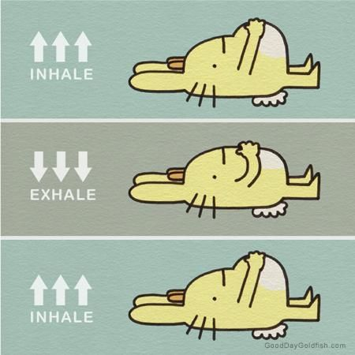
- Sit or stand with a straight spine. Close your eyes and put your hand on your stomach.
- Imagine that your stomach is a balloon. We are going to fill up your balloon with air.
- Slowly breath through your nose. As you are breathing, fill your balloon (stomach) with air. Feel your belly become larger as your balloon (stomach) is filled with
- Slowly exhale through your mouth and let the air out of the balloon completely. Your balloon (stomach) should become deflated.
- Repeat 3-6 times

Count Down

- Hold your hand out, inhale through your nose and count 1-2-3-4-5.
- Exhale through your nose while taking in your fingers count 1-2-3-4-5
- Repeat 4-6 times

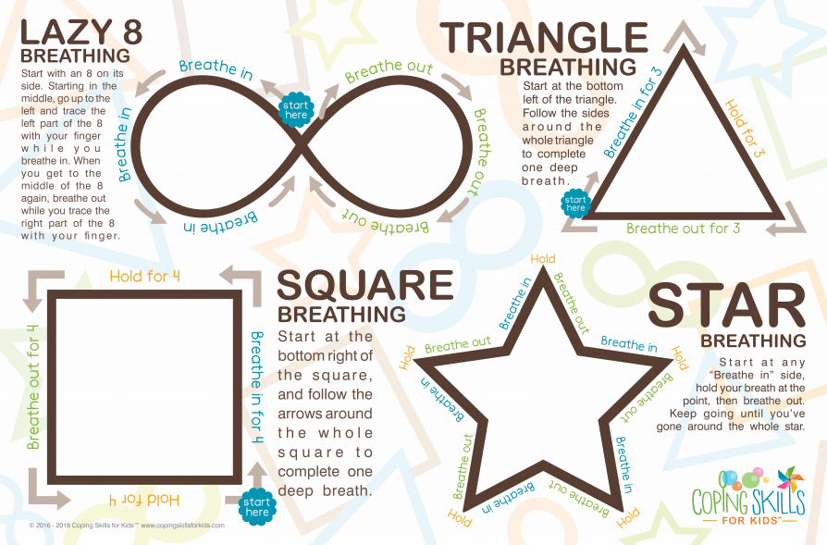

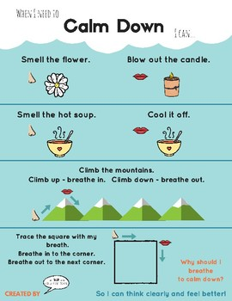

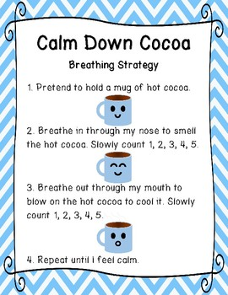
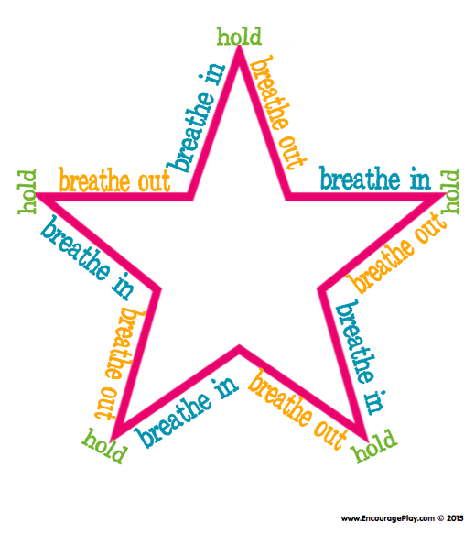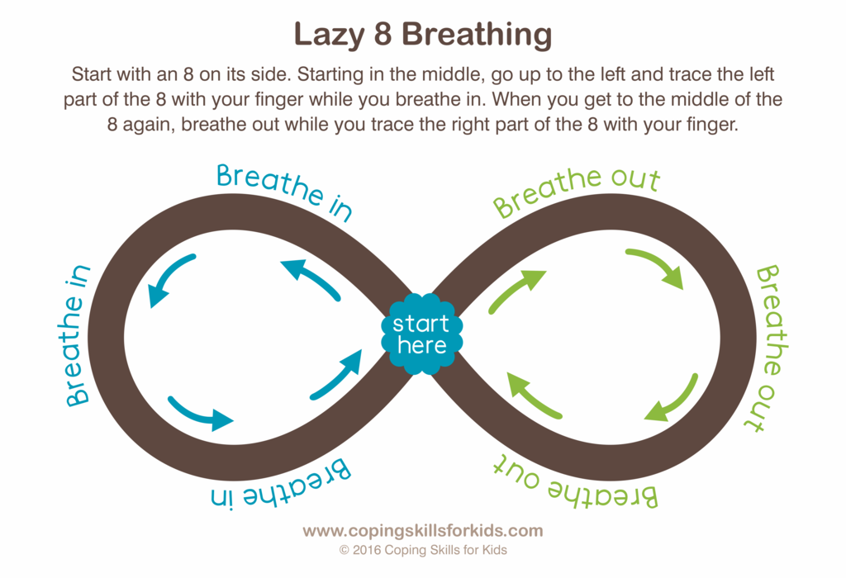

POSITIVE IMAGERY EXERCISES

- Get in a comfortable position. You can lie down or sit back in your chair.
- Close your eyes. Relax your mind and your body.
- I am going to count to 10, when I am at 10, you should be in a calm and relaxed state.
- Take 3 slow deep breaths.
- Clear your mind. If something comes to mind, put it inside a balloon and let it fly away slowly.
- Now imagine a calming place. One calming place is a blue ocean with the waves hitting the sand.
- You can use the ocean or your own calming place. Add details to your calming place.
- Continue to take deep breaths as you think about this calming place.
- The child can do positive imagery for 2-10 minutes
- When I count to 10, you can slowly open your eyes
- How did that feel?
.
Note:
Match the visual image according to what works for the client and child’s developmental level.
Positive imagery might be difficult for those with grief and loss since safe images or places can be associated with the person they lost. Some clients may not be ready for positive imagery

Mindful Meditation

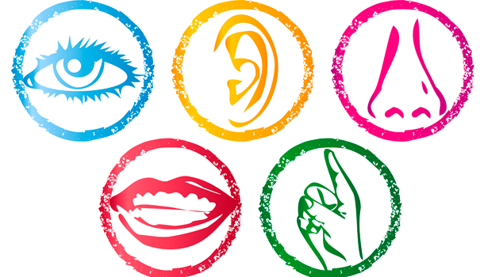

Mindful Meditation
- Get in a comfortable position. You can lie down or sit back in your chair.
- Close your eyes. Relax your mind and your body.
- I am going to count to 10, when I am at 10, you should be in a calm and relaxed state.
- Take 3 slow deep breaths. Allow your muscles to relax.
- Clear your mind. If something comes to mind, focus on your breathing, then put your thoughts inside a bubble and let it fly away slowly.
- Now, choose one of the below to focus on:
- Repeat a simple mantra.
- Focus on sounds inside your body the outside your body
- Your breathing
- Can repeat a positive statement
- Continue to take slow deep breaths. When you are done, slowly open your eyes.
- Can start with 3 minutes then increase the time slowly up to 30 minutes.

Mindfulness
Being present in the moment by using all 5 senses.

1. At any time, focus on what you see, hear, feel, smell, and taste.

2. While you eat, focus on what you are eating (i.e., texture, smell, where it came from, the colors etc.).

Calming activities
Write activities that are calming for you.
Examples:
Watch television Taking a shower or bath Cook or bake something Listen to music
Take a walk Taking a nap Buy something new Draw or color
Talk to a friend Read a book Go to the beach Write in a journal

Activity | When I can do it

My Relaxation Chart
Strategy: | Why it helps: | Introduced:
Deep Breathing
Muscle Relaxation
Positive Imagery
Meditation
Mindfulness

My Relaxation Log

Date/Time | Length: | Activity:

