**Foods II: Honors-Enterprise FN42 Syllabus** C:\Documents and Settings\greenea\Local Settings\Temporary Internet Files\Content.IE5\CR6FELI6\MC900153756[1].wmf Mrs. Burgess

Spring 2016 Room E100

**email:** [**angela.burgess@ucps.k12.nc.us**](mailto:angela.burgess@ucps.k12.nc.us) **Phone: 704-708-5530 ext. 1983**

**canvas:** [**https://ucps.instructure.com/courses/17286/assignments/syllabus**](https://ucps.instructure.com/courses/17286/assignments/syllabus)

This course focuses on advanced food preparation techniques while applying nutrition, food science, and test kitchen concepts using new technology. Food safety and sanitation receive special emphasis, with students taking the exam for a nationally recognized food safety credential. The **ServSafe®** employee certification provides increased marketability.

Students develop skills in preparing foods such as beverages, salads and dressing, yeast breads, and cake fillings and frostings. A real or simulated in-school food business component allows students to apply instructional strategies. English language arts, mathematics, and science are reinforced. Work-based learning strategies appropriate for this course include apprenticeship, cooperative education, entrepreneurship, internship, mentorship, school-based enterprise, service learning and job shadowing. Family, Career and Community Leaders of America (FCCLA) is a club you are welcome to join. This club will offer competitive events, community service, and leadership activities that provide the opportunity to apply essential standards and workplace readiness skills through authentic experiences. **Foods 1 is a prerequisite for Foods II**.

**Course Objectives:**

Upon the successful completion of this course, students will be able to:

* Evaluate causes of foodborne illness & analyze factors that influence food safety.
* Apply factors that influence food safety.
* Understand safe facilities, pest management and sanitation.
* Understand the Roadmap to Food Entrepreneurship and implement a food-related live project within the classroom for a target audience.
* Create specialty food preparation skills.
* Create preparation and service of yeast bread products.
* Analyze preparation and service of cakes, fillings, and frostings.

**Grading:**

Tests (7 Objectives) 45%

Labs/projects 15%

Class work (in-class & take home) 15%

VoCATS (EOC) 25%

Total **100%**

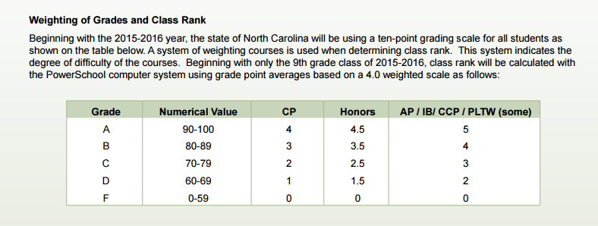

**Tests** will be given every week proceeding completion of each standard from each objective. There will be a county-wide benchmark assessment given at the end of every 4 ½ week Term (T1 & T2). The VoCATS test is a standardized test given at the end of the semester on exam days and counts **25%** of your overall grade.

**Labs** will take place on Thursdays and Fridays if it is a regular school week and weather permits. Labs on Friday will be evaluated and recorded as a lab grade. If you are absent, you are expected to make-up the lab by doing the alternate assignment. This is located on my canvas page listed above.

**Classwork/homework** is assigned daily. It is expected to be completed in the time allotted for class and must be your own work. Please make sure to *check the canvas or communicate with me regarding work when you are absent.*

**Quizzes** will begiven after each objective. All questions are available on the canvas website. You can study ahead of time using this resource.

**Supplies REQUIRED for class:**

You will need to bring the following supplies per student:

1. Hair restraints (chef hat, hat, hair restraints, hair ties)
2. 50 PCS Food Service Plastic Cleaning Disposable Gloves **$5.73 FREE shipping~Walmart**
3. Paper plates, cups, forks, spoons (Quantity- 50 each)