Marvin Ridge High School Spanish

August 2019 – January 2020

Welcome to Mrs. Elliott’s Spanish class!
Spanish II students will continue the development of their listening, speaking, reading, and writing skills as they study past, present, and future time. Culture, geography, and grammar will be studied in greater depth in Spanish II. Also, we will have a strong technology component throughout the course to develop students’ 21st Century Skills. This course will be taught and conduced mostly in Spanish. English will rarely be used.
• To create classroom situations in which the Spanish language is needed to communicate about and comprehend topics of interest to the students.
•. This is a Novice-High level course that expects a prior foundation of knowledge and proficiency that permits the students to work at this level.
• To motivate students to study Spanish as a second language.
• To expose students to the Spanish-speaking world. I can’t wait to explore the Spanish Language and Culture in class.
REQUIRED SUPPLIES
BRING TO CLASS EVERYDAY
- Binder – 5 tab dividers.
- Pencils
- Blue/Red Pens
- Yellow Highlighters
- Computer
- Ear buds.
- Expo-erasable marker (1)
- Single white sock.
CELL PHONE POLICY
- Cell phones and all other electronic devices are only allowed at teacher’s discretion for educational purpose during class.
- Please place your phone on the phone pocket holder before class begins.
TARDY POLICY

- Students are expected to be in their seat ready to work when the bell rings.
RESTROOM PASS USAGE

- You CANNOT leave the classroom without Teacher Approval and sig
- You are also required to carry the classroom hall pass when leaving the room.

CONTACT INFORMATION
- E-mail: Alejandra.elliott@ucps.k12.nc.us
Students MUST contact me using their school email accounts.
- Tutoring: Tues. from 3:05-3:35 p.m.

KEY TO SUCCESS
- POSITIVE Attitude
- Important to review/study vocabulary every day for 20 minutes.
- No one but YOU can memorize.
- Use the language as often as you can! Listen to music and podcasts, watch TV and movies in Spanish
- When you find a Spanish speaker start a conversation. ---------------------------------
“If you talk to a man in a language he understands, that goes to his head. If you talk to him in his language that goes to his heart.” Nelson Mandela
MAKE-UP WORK
- Students have two days to make up the work missed for each day absent. When arrangements are not made to complete the work the student will receive no credit. Students who have an out-of-school suspension and students with unlawful absences and tardies, are encouraged to make up all missed work but are only allowed to make up major tests or projects for credit and take semester exams. Teachers will record zeros on daily work for out of school suspensions only when the entire class was required to do work for which a grade is recorded.

- It´s the student´s responsibility to make up his/her work.

- In order to make up a quiz, test, exam or some other assignments the student must be afterschool in my classroom.

GRADING SYSTEM
- Daily Work: 15 Points.
- Quizzes & projects: 30 – 80 Points.
- Homework: 10 Points.
- Exam: 100 Points.
- Class Participation:
  - 1st quarter 20 pesos
  - 2nd quarter 30
pesos.
  - 3rd quarter 40 pesos.

- Assignments not turned in on the due date will be marked as 0 in the grade book.

HOMEWORK/PROJECTS
- You will be assigned homework assignments as needed.
- Work not finished in class will also be assigned as homework.

ACADEMIC HONESTY
- Cheating and/or Plagiarism will NOT be tolerated under any circumstances.
- This includes copying another student’s work or letting them copy your work.
- During testing: cell phones, notes, textbook, dictionaries, etc… are not allowed.
- Homework: use of online translator/word processor auto-correct feature is prohibited. Violation of this rule will result in a zero.

LATE WORK POLICY

Homework is due at the beginning of class. It will be considered late if not turned in at that time. LATE WORK includes any assignment in any category.
- Late work will be worth a maximum of 50% and be accepted the following day of returning to class. No credit will be given for work not turned in within this time frame.

CLASSROOM EXPECTATIONS
- Demonstrate high quality work.
- Do not speak while your teacher speaks
- Use as much Spanish as possible. Perseverance and effort, not perfection, are the keys.
- Be an active listener
- Be positive. Criticizing and/or complaining will only work against you.
- Eyes on the speaker
- Bathroom use is limited.

DID YOU KNOW?
- Students who have studied a foreign language earn higher scores on standardized tests (SAT/ACT/GRE/LSAT).

- Students who take AP Spanish classes and receive a 3 or above may earn up to 20 college credits. Please check with an advisor at the college of your choice.
- Spanish is the 2nd most spoken language in the US and there are 400 million Spanish speakers in the world.
- Spanish is the official language of 22 countries, the 2nd language most used for international communication and 3rd most used on the internet.
- Spanish is the 2nd most studied language in the world.
- Knowing the culture of other countries is a major advantage for careers in today’s global economy.
Language Learning Strategies:

- Read it.
- Write it down.
- Say it out loud.
- Use it in a sentence.
- Have a friend quiz you.
- REPETITION IS THE KEY TO LEARNING.
- Take notes in class. Review them. Add to them.
- Make neat vocabulary flashcards and practice them every day.
- Put forth the effort to learn for the whole 90 minute class.

A Notes from Mrs. Elliott: Vocabulary quizzes will not be announced in advanced. You are expected to practice the vocabulary in a daily basis, using www.quizlet.com if needed.
BE ORGANIZED! Maintain an organized binder/folder with the Spanish material that you receive in class.

Sra. Elliott dismisses the class – Not the bell when:
- All material are placed in the appropriate place
- All trash is thrown away.
- All desks and chairs are in the appropriate place.
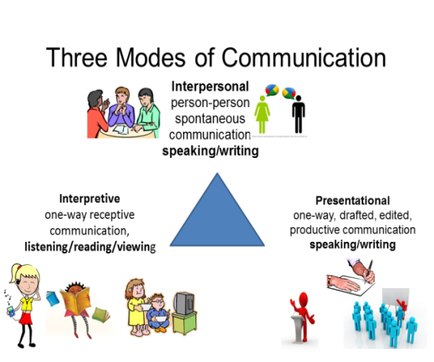
WHAT YOU WILL LEARN

