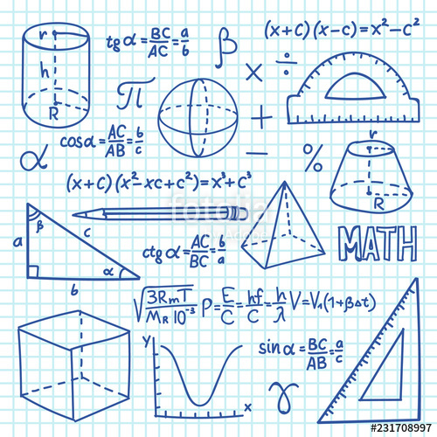

Mrs. Meuschke’s

8th Grade Mathematics Class

**Supplies**

* 1 ½” Binder
* Filler Paper
* Pencils
* 8pk. Colored pencils
* 2 Composition book
* Ear Buds
* Tissue
* Ruler
* Highlighter

Tutoring Schedule

* Tutoring during LUNCH and Recess with Ms. Louprette.
* Contact Ms. Louprette for tutoring.

**Sign (Parent) ___________________________________________**

**SIGN (sTUDENT)**

HOMEWORK EXPECTATIONS

Homework will be assigned Monday thru Thursday except when otherwise stated. Homework is essential to ensure that scholars do well on tests and prepare them for High School. It will help scholars master the topics learned in class. All Homework will be turned in at the beginning of class on Friday of the week given and graded for accuracy. **The expectations for Homework will be that it is neat, complete, and accurate.**

**Homework will be given in the form of:**

1. **IXL**
2. **Math worksheets**
3. **Math Projects**

If you have any questions about homework, my door is open at 8am for extra help.

**Late Homework or Assignments** will be accepted till one week after at a penalty of 10 points



.

**Grading **

**Skill Practice 10%**

**Formative Assessments 45%**

**Summative Assessments 45%**

**Skill Practice \*** Homework and Participation / **Formative**\* Warm-ups and Exit tickets / **Summative**\* Unit Test, Quizzes and Benchmarks

**Contact Information**

Ms. Thomas

(704)296-3120

Nina.Thomas@ucps.k12.nc.us



Ms. Thomas’

8th Grade Mathematics Class