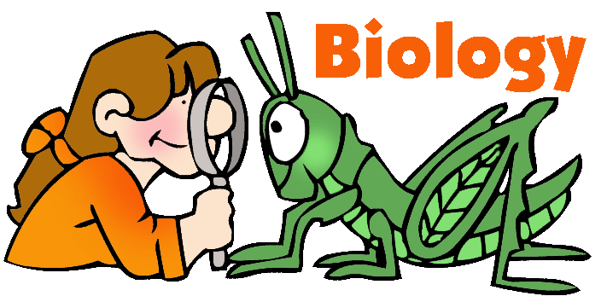
Welcome to BIOLOGY!!

CURRICULAR GOALS
- NC Essential Standards
  - Structure and Function of Living Organisms
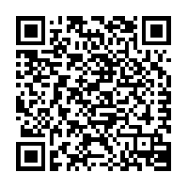
  - Ecosystems
  - Evolution and Genetics
  - Molecular Biology

(The entire course of study can be found using the Q.R. Code or web address http://www.ncpublicschools.org/docs/acre/standards/new-standards/science/biology.pdf)

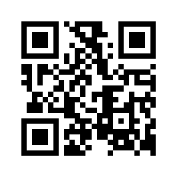
- Common Core - The standards are designed to be robust and relevant to the real world, reflecting the knowledge and skills that our young people need for success in college and careers. With American students fully prepared for the future, our communities will be best positioned to compete successfully in the global economy

(The entire Common Core Standards can be found using the Q.R. Code or web address
http://www.corestandards.org/)

- Students will learn using lectures, investigative laboratory experiments, reading, completing interactive activities with the internet and technology, and with reports and projects.

CUTHBERTSON BIOLOGY SYLLABUS
Can be located in Canvas

REQUIRED MATERIALS
- Laptop - Biology handbook - 3 ring binder (1½ inch) - Composition Notebook
- Notebook paper - Colored pencils - Pencils - Black/Blue pens
(No colored ink)

HANDBOOK
You will be given the required notes and assignments for the course in one packet. The handbook is a REQUIRED material and must be present in class EVERDAY

ATTENDANCE
Students are responsible for all material presented in class. If you are absent, it is your responsibility to check with me about the assignments that you have missed. I keep all make-up work in a designated folder that has your name and date of assignment. Exams, quizzes, labs, and homework often include questions on material presented only in class, so performance on these indirectly reflects attendance.

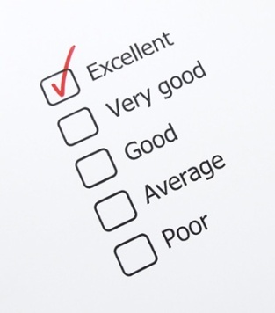
EVALUATION
- Participation will be a major part of this class. Points may be taken away if you do not remain on task.
- Daily Warm-ups and Ticket out the Door
- Progress Checks – Daily assignments are used to complete the assignment
- Homework assignments: Homework is designed to further your understanding and is to your benefit to complete. Class work not completed in school should be considered homework.
- Tests will be always announced and will correlate with the lessons.
- All exams, projects, papers, and labs must be completed in order to receive credit in this course.
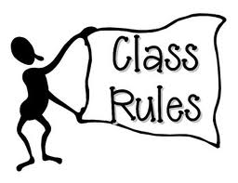

Classroom Rules & Procedures
The following rules have been created for the assurance of promoting an optimal learning environment in which all students can succeed. Please read the following carefully you will be required to then sign and date.

- Be seated, quiet, MATERIALS READY TO GO with all electronic devices put away and turned off, by the time the bell rings. If I see it or hear it, the electronic device will be taken away and given to the principal’s office.
- Come to class prepared. Bring a pencil/pen, composition book, and your REQUIRED handbook every day. Have your materials out and ready by the time the bell rings.
- Begin the “Warm Up” exercise by the time the bell rings. We will go over the warm up approximately 10 minutes after the bell rings.
- No eating; this is a lab classroom, and as such we use different materials which may be harmful is ingested. However, you may bring something to drink as long as it has a lid. NO CANS or OPEN CUPS
- Keep work area CLEAN. Throw away any garbage at or around your desk and remain seated until you are excused.
- Respect personal space and property.
- Follow all directions the first time they are given.
- Being on time is important to your success in my class. I will follow the BHS tardy policy strictly. For further information, refer to the BHS student guide.
- This is YOUR classroom. Any acts of vandalism will result in an automatic referral to administration
- DO YOUR OWN WORK & NO COMPLAINING Cheating of any kind is NOT tolerated and will result in a FAIL grade, a call home, and you will be referred to administration. Don’t do it, it’s not worth it.

DISCIPLINARY POLICIES
- Every offense warrants action, but the action depends on how serious the offense is and how many times you have repeated the behavior
- We are in this classroom for one purpose only – TO LEARN. Disruption of the class, challenges my role as a leader of the class, and lack of participation in the class all make our goal harder. Therefore, for both your sake and in the best interest of your classmates, you will be disciplined for violations of both school and class policy.
- First Minor Offense:
Verbal warning/ The “look”
- Second/Slightly Disruptive Offense:
Lunch/After-School detention (1st offense 20mins, 2nd 50mins)
- Third Offense:
Parent phone call; Removal to hallway/Private conference with teacher
- Fourth Offense:
Disciplinary referral; Immediate removal from class to the office

MAKE-UP AND LATE WORK POLICY
- Make-up work will follow the school’s policy. You will have 2 school days to make-up any work that you may have missed.
- The penalty for late work is two points for every assignment; unless told otherwise

EXTRA CREDIT
There are several ways to earn extra credit for those who have all their assignments completed but feel they need it:
- I will assign small opportunities throughout the semester. Take advantage when I do
- LATE PASS - You may bring in 2 laboratory supplies to earn for homework pass.
Laboratory supplies such as:
- Paper towels - Kleenex - Cleaning Supplies
- Colored pencils - Hand sanitizer - Baby wipes

Late passes can be used on a completed late assignment but receive full credit

GRADING SCALE
I grade on a total point scale. Tests are worth more than quizzes, and quizzes worth more than homework. However, they are not weighted into categories.

Example: Total points correct
___________________ X 100 = Student’s
Total points of Percentage
Assignment

Year Grade: The year grade is calculated as follows:
25% (Term 1) + 25% (Term 2) + 25% (Term 3) + 25% (EOC)

HALL PASSES
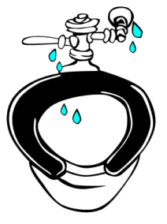
You will be given a pass that will allow you to use the restroom SIX TIMES FOR THE ENTIRE SEMESTER (this means the pass for ALL 3 TERMS). Once the pass is completely used and/or you have lost your pass you are not permitted to leave the classroom. If you have not used your pass you will be given extra credit at the end of the year (MUST HAVE THE PASS FOR THE EXTRA CREDIT)

HELPFUL REMINDERS:
- I am here to help! Don’t wait until the end of the quarter to get help.
- Talk to me! I know life exists beyond the classroom if there is an issue that is affecting your academics let me know I will work with you.
- Check my Moodle Page: access through the Cuthbertson High School website wiki

Please review the Cuthbertson Biology Syllabus and Course of Study that
is posted in Canvas.

Please have your parent/guardian sign the parent letter handout indicating that you have reviewed the class policies, Cuthbertson Biology Syllabus and complete the Google form located in Canvas.

Tell me and I forget, teach me and I may remember, involve me and I LEARN
― Benjamin Franklin

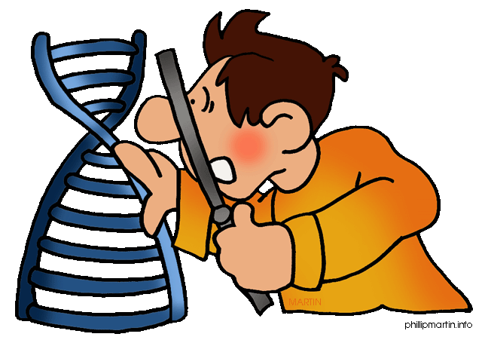

Do not remove from notebook – Should be kept in front of notebook at times

