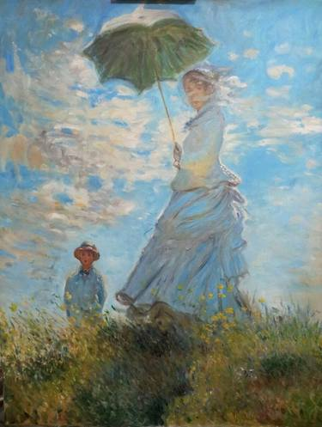  Classroom Expectations  - Soyez à l’heure!  - Soyez prets!  - Homework finished.  - Bathroom visited  - Warm-up begun.  - Soyez respecteux!  - Soyez aventureux! |  |  | AP French Overview  AP French is a year-long, AP level course designed to strengthen the skills acquired in French I, 2, 3 and 4 and advance to higher levels of speaking, listening, reading, and writing proficiency.  This course will be a combination of critical thinking activities, independent work, group work and creative projects.  Congratulations for accepting the challenges of this advanced level course. Bon Courage!  Exam Date: Friday, May 15th at 8am  Grading Scale  50% Tests & Projects  30% Quizzes  20% Homework & Classwork  Classroom Supplies  1. Binder with loose-leaf paper and dividers.  *We will set up dividers as a class – 6 tabs*  2. Pencils and pens (pens are to be used on the AP Exam for the writing portions)  fsagggggggggggggg |  |  | Français 5/AP – honors/AP  - Mme Brooke Souther ● Brooke.Souther@ucps.k12.nc.us

AP French Themes  - Families and Communities /La famille et la communauté  - Personal and Public Identities / La quête de soi  - Contemporary Life / La vie contemporaine  - Global Challenges / Les défis mondiaux  - Beauty and Aesthetics /L’esthétique  - Science and Technology /La science et la technologie |  |  | Un effort partagé (a shared effort)  Teacher – I vow to…Be available for conferences, provide extra help & lead the adventure for new discoveries.  Parent – Monitor student attendance and homework and be supportive of teacher efforts.  Student – I vow to… Participate, be prepared for class, and be present (physically and mentally).  ___________________________________________________  Parent Signature  ___________________________________________________  Parent E-mail (please write legibly)  ___________________________________________________  Student Signature |  |  | Classroom Expectations & Participation Points  Parents – please make sure that you read these two documents as well. Your signature verifies that you have read them along with this one.

