Classroom Behavior  - Soyez à l’heure!  (Be on time for class!)  - Soyez prets!  (Be ready for class!)  - Homework finished.  - Bathroom visited  - Warm-up begun.  - Soyez respecteux!  (Be respectful)  - Soyez aventureux!  (Be adventurous)  - Have an open mind! |  |  | Fun Facts about French!  It’s spoken on 5 continents!  It is the second most widely learned foreign language and over 200 million people speak French.  It’s a language of international relations.  It’s one of the official languages of the EU, the United Nations, UNESCO, NATO and the Olympics.  It’s spoken by celebrities!  To name a few…Bradley Cooper, Audrey Hepburn, Johnny Depp, Joseph Gordon Levitt, Tony Parker and many more!  Grading Scale  50% Tests & Projects  30% Quizzes  20% Homework & Classwork  Classroom Supplies  1. Binder with loose-leaf paper and dividers.  2. Pencils and/or pens  fsagggggggggggggg |  |  | Français 2  - Mme Brooke Souther ● Brooke.Souther@ucps.k12.nc.us

French 2 Overview  - Physical descriptions  - Around the house & town  - At the market  - Martinique  - Past Events  - French Castles |  |  | Un effort partagé (a shared effort)  Teacher – I vow to…Be available for conferences, provide extra help & lead the adventure for new discoveries.  Parent – Monitor student attendance and homework and be supportive of teacher efforts.  Student – I vow to… Participate, be prepared for class, and be present (physically and mentally).  ___________________________________________________  Parent Signature  ___________________________________________________  Parent E-mail (please write legibly)  ___________________________________________________  Student Signature |  |  | 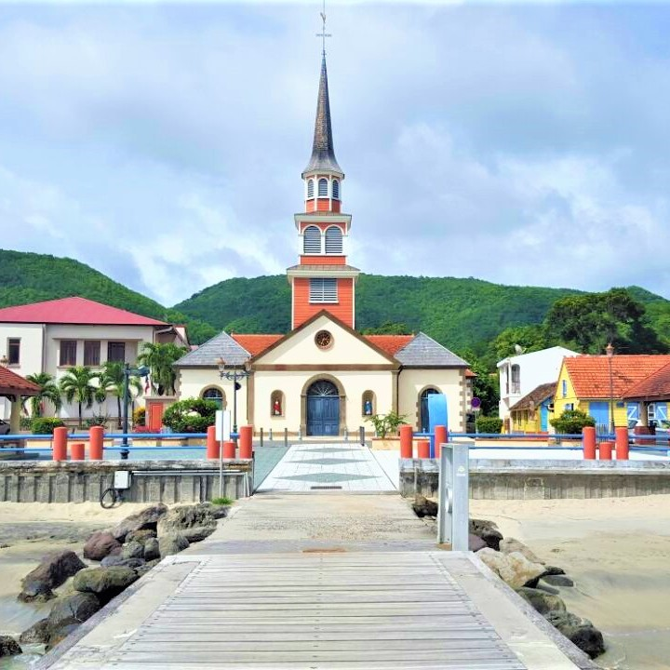  Classroom Expectations & Participation Points  Parents – please make sure that you read these two documents as well. Your signature verifies that you have read them along with this one.

