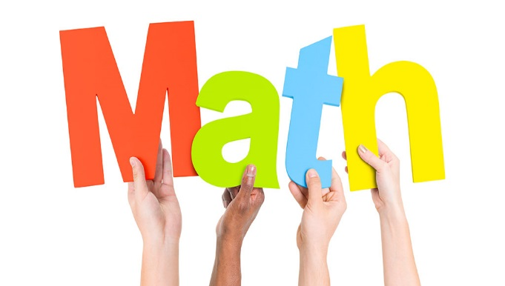 |  | 8th Grade Math  - ~Mrs. Blalock  - 2019-20

Dear Student and Parent,
Welcome back to school and to my 8th grade math class. I am excited about all of the things we will learn throughout the year. If at any time you have questions and/or concerns, please feel free to contact me via email (gina.blalock@ucps.k12.nc.us) or by calling the school (704-296-6350) during my planning time (10:30 – 11:30). In addition, I am available during my Office Hours on Thursday mornings from 7:30-8:00. If you plan to take advantage of this before-school assistance, please notify me by Wednesday so I can plan accordingly.
Please read, sign (on the back) and return this overview of our 8th grade math class to school as soon as possible. Mrs. Blalock

Student Responsibilities:

- Bring all materials and completed assignments to class every day.
- Always correct homework, quizzes and tests in order to learn from your mistakes.
- Update your Agenda daily (at the beginning of class).
- Check Canvas, daily folders and with the teacher following an absence for make-up work…this is YOUR responsibility!
- Turn assignments in when they are due.

Supply List:

1-in Binder
Notebook Paper
Pencils
Red pens (for grading)
Dry erase Markers
Spiral or cow notebook
5 dividers/tabs

Assignments:
Classwork/Homework 40%
Quizzes: 20%
Tests: 40%

Grading Scale:
A 90-100
B 80-89
C 70-79
D 60-69
E <60
NOTES:
Notes will be taken in a spiral or cow notebook. They should be labeled with the title and date for easy reference, as well as listed in the Table of Contents. In addition to notes, all examples from the lesson should be written down neatly. This will assist you at home when completing homework, as we do not have a Math textbook.

CLASS/HOMEWORK:
Math is a sequential subject in which each lesson builds on the days/weeks before. In order to be prepared for the next day’s lesson, it is critical that assignments be completed and turned in ON TIME! Late work MAY be accepted with points deducted, depending upon the circumstances. All work should be completed in PENCIL and placed in the appropriate section of your binder. SHOWING YOUR WORK is required for all problems, unless otherwise indicated.

WEEKLY MATH:
These assignments consist of approximately 20 problems per week. These problems provide a spiral review of material and will help you retain skills already learned. Weekly Math will serve as our Warm-Up every day. We will focus on the problems for that day – allowing time for teacher explanation and student work/questions. Weekly Math assignments WILL NOT be sent home with students since this teacher-supported time will be provided each day in class. You should not work with another student - YOU MUST DO THE WORK BY YOURSELF! Weekly Math problems will sometimes be on CANVAS and other times on paper. When problems are NOT on the computer, students will exchange papers to grade, allowing for immediate feedback and correction. If your answer cannot be read due to messy writing, it may be counted wrong.
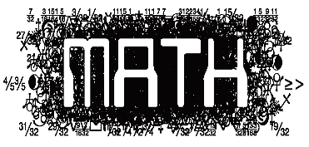
ASSESSMENTS:
QUIZZES are given on a regular basis to determine student comprehension. TESTS are typically every two to three weeks – at the end of a unit. SNAPSHOTS (previously known as Benchmarks or Common Assessments), as well as NC CHECK-INS, will be given several times throughout the year as mandated by the County.
EXTRA CREDIT:
I do not offer extra credit to individual students. If you do what is expected of you in class, and are giving your best effort on assignments, there should be no need for Extra Credit. There will, however, be opportunities throughout each grading period to complete optional assignments for additional points.
#1 CLASS RULE:
RESPECT yourself and others, all property and the opportunity to learn. If we are all following this ONE RULE, we will have an AWESOME school year!

