AFM  Teacher: Jennifer Joy  Email: Jennifer.joy@ucps.k12.nc.us | 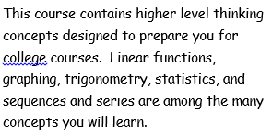
CLASS MATERIALS  - 3 ring notebook  - Paper  - Pencils  - Folder with pockets  - TI 83 or 84 calculator  - Charged chromebook | GRADES  - Tests –count twice (200 points)  - Quizzes-count once  (50-100 points)  - Classwork/Homework  (2 points each)  - Projects-count twice(200 points)
EXPECTATIONS  - Make sure to be prepared for class.  - Always be respectful.  - There will be no cell phone or other distracting devices used during class time.  - Have all assignments completed on time.  ***Food is not permitted in class.  ***Drinks with lids are allowed. | EXTRA INFORMATION  - Cell phones will put away every day. There will be a designated location for students to place their cell phones.  