Welcome to Mrs.Hall’s Math 1 Class
August 2019
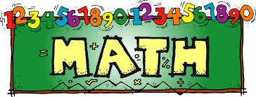  This is a year long class. We will cover 9 units and will take our time to ensure that all students are grasping the content. Please ask for tutoring as soon as you need it, do not wait until test time.  The units we will cover are:  - equations/expressions  - Data and statistics  - Functions  - Linear functions  - Exponential Functions  - Quadratic functions  - Systems of equations/inequalities  - Geometry  - Exponent rules and polynomials | Cell phones are a constant distraction in class. School policy is that they are put away, out of sight, and silent. Your students will be bringing home a contract I require them to sign stating what my expectations are as far as cell phones. Please read the contract with your child and I ask that you both sign it so that I know we are all in agreement about where cell phones should be in my classroom.
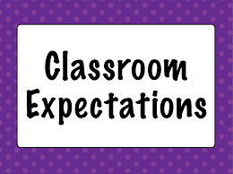  - Give 100% at all times  - No eating in class  - No phone use in class  - Be respectful  - Remain seated  - Follow Adult directions  - Be prepared | Grading Policy  40% Tests  30% quizzes  20% Classwork  10% Binders
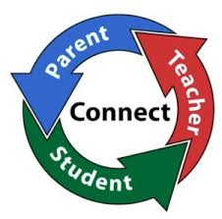  It is very important that we work together to ensure the success of your child. I will promise to contact you if I see a need and ask that you do the same. I can be reached by phone at (704)296-3130 or email me at lori.hall@ucps.k12.nc.us  I do offer tutoring after school most days. Just confirm with me during class that day that I am able to stay. | There will not be any homework assigned. However, it is the expectation that any work not completed in class will be completed at home and be handed in the next school day.
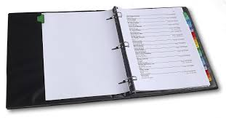  I do require that students keep a binder in class. They will keep detailed notes and examples in this binder to use for reference. All work to be graded must remain in this binder and they will be graded periodically during a grading term | - 1.5 inch binder (no paper needed)  - Pencils  ** wish list**  Black or Blue Expo markers  Copy paper  Pencils
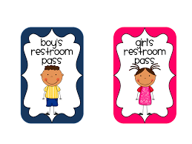
Everyone will be given 6 bathroom passes to use each 6 weeks. If your child needs more than that due to a medical condition please let me know. Any pass not used will be counted as extra credit at the end of the marking term.

