Name__________________________________ Date: 11/24/15 Period:_______
Global 1: Effects of the Black Death
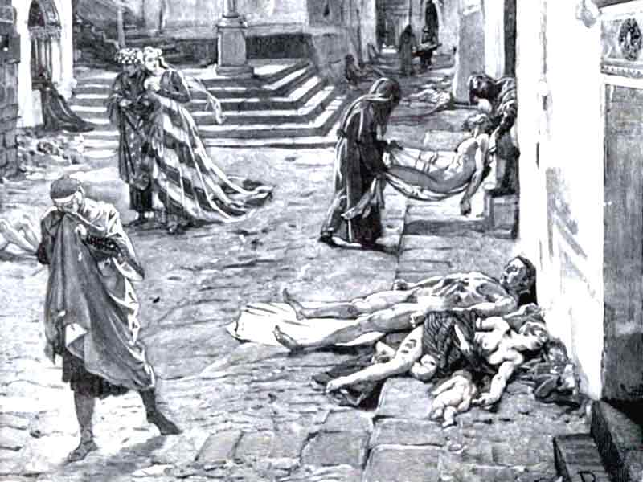
The Black Death was the most devastating pandemic in human history. It was a disease caused by bacteria that spread through Europe, Asia and the Middle East killing millions of people in the process. The effects of the Black Death were far-reaching and long-lasting because of the terrible death rate. In less than 200 years the disease completely shifted the course of human history.
The Black Death was an epidemic which meant it spread far and wide and infected millions of people.
Why do you think it was so easy for the disease to spread in a place like Medieval Europe?
_____________________________________________________________________________________________________________________________________________

- What was the Black Death and where did it spread?
____________________________________________________________________________________________________________________________________________________________
The Black Death spread through Europe from 1333 AD to around 1600 AD and killed more than half of the people living in the entire continent in the process. The effects of this massive loss of life ranged from economic to social to political because members of every social class in Europe were killed.
Filthy peasants weren’t the only Europeans to die from the plague. Nobles, scientists, church officials and even kings died from the disease.
Why do you think it was easier for the disease to spread to a peasant than it was for it to infect the king?
____________________________________________________________________________________________________________________________________________________________________________________________
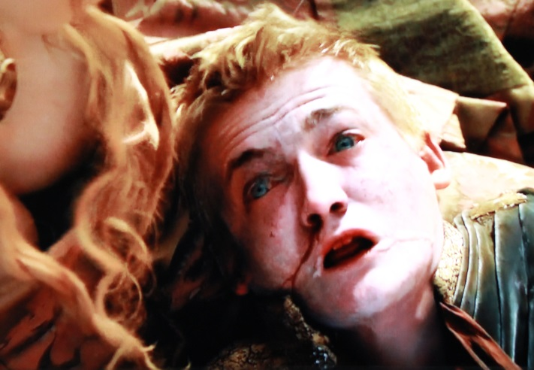

- Why were the effects of the Black Death so widespread and devastating?
__________________________________________________________________________________________________________________________________________________________________________________________________________________________________________
The first institution in Europe badly damaged by the Black Death was the economy. The economy of Europe had been slowly recovering thanks to the development of capitalism but the outbreak of the disease ruined all that. The danger created by the disease made it impossible for trade to continue and the purchase and sales of goods declined sharply in the 1350’s.
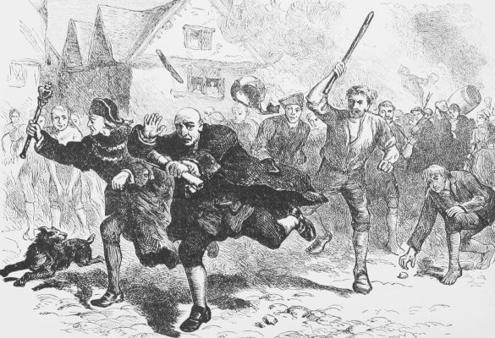
Many merchants who tried to sell their goods to towns in Europe were either killed by the Black Death or attacked by townspeople who were terrified that outsiders would bring the disease into their towns.
Would you trust a stranger during a time of plague like the 1300s? why or why not?
_________________________________________________________________________________________________________________________________________________________________________________

- How did the Black Death affect trade in Europe during the 1300s?
____________________________________________________________________________________________________________________________________________________________
The Bubonic Plague also killed so many workers that it was difficult for European farms and workshops to create enough products to sell at all. People starved to death in the streets of towns because farmers in the fields were too sick to harvest and transport their crops. As a result, Europe’s economy sunk back to where it was after the fall of Rome.
Most farmers in Medieval Europe were not educated so it was difficult for them to understand the danger of the Black Death. Millions of farmers died in their fields while trying to grow crops for Europe.
How would widespread death of farmers affect New York City today? Why?
_____________________________________________________________________________________________________________________________________________________________________
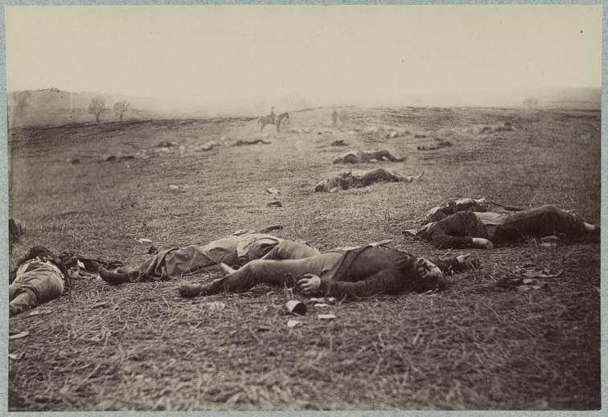

- Why did the arrival of the Black Death hurt the food supply and economy of Europe so badly?
__________________________________________________________________________________________________________________________________________________________________________________________________________________________________________
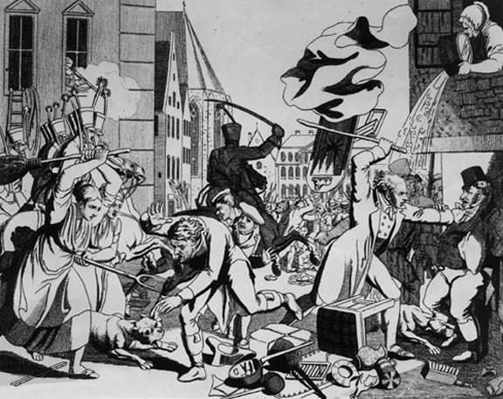
The people of Europe did not respond well to the changes caused by the Black Death. Many peasants did not understand where the disease came from or how it was spreading so they made up their own explanations. Christians blamed Jews for “poisoning the water supply” or using dark magic to infect the air with the bacteria. Thousands of Jews were persecuted and many of them were killed in the hysteria caused by the unstoppable spread of the disease.
Most Jewish people lived in separate settlements from Christians called ghettos. The ghettos were isolated from Christian populations so many Jews never caught the disease. Christians used this as evidence that the Jews were causing the Black Death
Do you think it was fair for the Jews to be blamed for the spread of the Black Death? Why or why not?
____________________________________________________________________________________________________________________________

- What group of people became unwilling victims in the hysteria that happened during the Black Death? Why?
__________________________________________________________________________________________________________________________________________________________________________________________________________________________________________
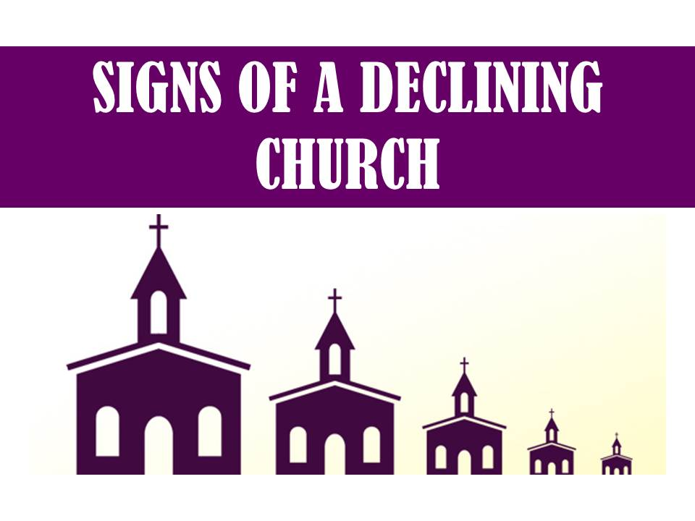
Other Christians turned to the church for help and asked priests to pray for the Black Death to end. Thousands of people flocked to European churches and spread the disease even further by gathering in large groups to pray. Many priests became infected while trying to help the sick and it became apparent that the church could do nothing to stop the spread of the disease. Millions of Christians lost faith in the church and the power of the Pope faded.
Many Christian Europeans asked the church to save them from the Black Death. When the church proved unable to do this, most people stopped believing in its power and stopped paying taxes to the Pope.
How would you feel if you were a Christian living during the time of the Black Death and the Church turned out to be powerless? Why?
________________________________________________________________________________________________________________________________________________________________________

- How did the Black Death affect the Catholic Church? Why?
________________________________________________________________________________________________________________________________________________________________________________________________________________________________________________________________________________________________________________________
Name__________________________________ Date: 11/24/15 Period:_______
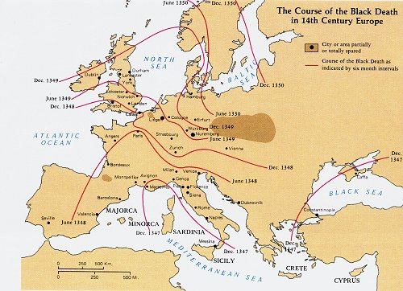
Global 1: Effects of the Black Death Homework

- The map shows that the Black Death
(1) began in England and Ireland and then spread eastward
(2) spread slowly over several decades
(3) affected most areas of western Europe
(4) was most severe in Italy

- The bubonic plague affected economic development in medieval times by
(1) encouraging the introduction of new types of crops
(2) causing production to decline and prices to rise
(3) sparking the ideas of socialism and reform
(4) destroying the guild system

- What was a direct result of the Black Death in Europe?
(1) The rate of urbanization increased.
(2) A shortage of workers developed.
(3) Food crops had to be imported from the Americas.
(4) German states dominated trade in the eastern Mediterranean.
4. Which of the following is an example of the effect of the Bubonic Plague on the behavior of Medieval Europeans?
(1) Spread of classical learning
(2) reintroduction of Greek art and architecture
(3) persecution of Jews and mass hysteria
(4) rapid scientific speculation

- The Black Death had a large effect on the Church because
- The inability of the clergy to provide a cure eroded support from parishioners
- The reestablishment of papal trade routes allowed for higher taxes to be levied
- The development of scientific advances conflicted with the teachings of the church
- The disease created new political movements that revolutionized Christianity

- In your own words, what do you think Europe would be like today if the Black Death had never spread there? Why?
___________________________________________________________________________________________________________________________________________________________________________________________________________________________________________________________________________________________________________________________________________________________________________________________________________________________________________________________________________________________________________________________________________________________________________________________________________________________________________________________________________________________________

