May 18-22nd, 2020

Reading
~Monday and Thursday~
35 Minutes a day!
Video 1: Retelling A Story
Goal: We will retell a story independently, including the characters, setting, beginning, middle and ending.
Raz Kids  Independent Reading with leveled readers |  | Raz Kids  Independent Reading with leveled readers.
Word Study
~Monday and Thursday~
10-15 minutes
Pick two or more activities to try this week!
Video 1: Red Hot Popcorn Words Review
Video 2: Letter and Sounds Review
Video 3: Vowel Intensive Review
Video 4: Blending Words
The words of the week: help, too
Choose one or two words from the list that you do not know. Review all sight words. Below are ideas for practice!
Write it 10 times. (choose)  Write it fancy, write it neat, bubble write it, write your words with red vowels and blue consonants | Look for it in books.  (Write each letter on a piece of paper-mix them up and then build sight words.) | Write it in craft sand, or just some dirt that you have outside.  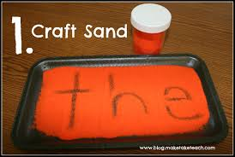 | Write words with a white crayon and then watercolor paint or use a marker to color over them.  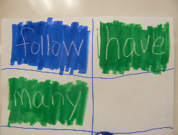 | Use your playdough and a toothpick to “write the words”.  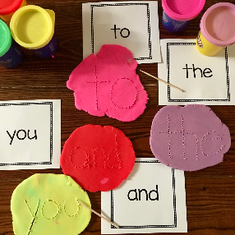

Social Studies
~Monday and Thursday~
Goal: We will understand how things change over time.
People change over time.  Ask a grown up to help you find a baby picture of yourself and a recent picture of yourself. Put the two pictures next to each other. Discuss with a grown up or sibling how you have changed and how you have stayed the same.  Baby Mrs. Delgado and “grown-up” Mrs. Delgado  .  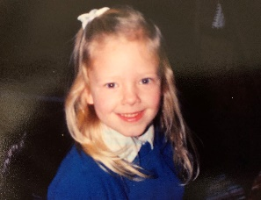  5 year old Mrs. Redding/ 35 year old Mrs. R  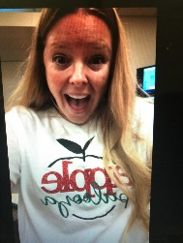  Young Mrs. Camp...Old Mrs. Camp  Young Mrs. Henning...OLD Mrs. Henning | Seasons change over time.  Draw a picture of what your yard looks like right now in the spring. Then draw a picture of what your yard looks like in the summer or in the fall. What changes in your yard from season to season?  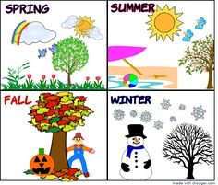  Young Mrs. Varieur… OLD Mrs. Varieur  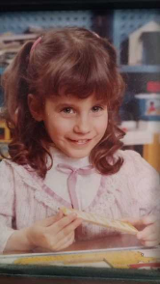  Young Mrs. Levy...Old Mrs. Levy

Math
~Tuesday and Friday~
45 Minutes a day!
Video: Quack and Count
Video: YouTube Read Aloud: One Is A Snail, Ten Is A Crab
Goal: We will decompose numbers to 10.
Iready: Number Partners for 8 and 9 | Iready: Number Partners for 10
Problem solving:  Video: Decomposing Bowling  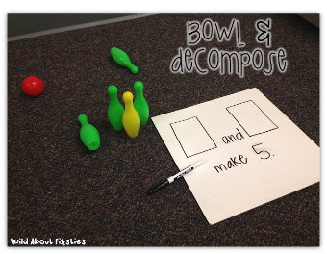  A great way to practice is BOWLING. Even if you don’t have bowling pins at your house, you can get creative. Add a little water to some bottles you have around. Roll a ball and see how many you knock over. If I set up 8 bottles and I knock over 3, I know that I have 5 more to knock over. The combination of 8 here is 3 and 5 make 8. Do this over and over and see how many different combinations you come up with. You can do 10 bottles, 6 bottles, or any number 2-10. | Activity: Decomposing 10 Chain  Need: colored paper/scissors/glue or tape or stapler  Cut strips of colored paper. Ask your child to show you a combination of a number from 2-10. Use the different colored paper to make combinations.  EX.  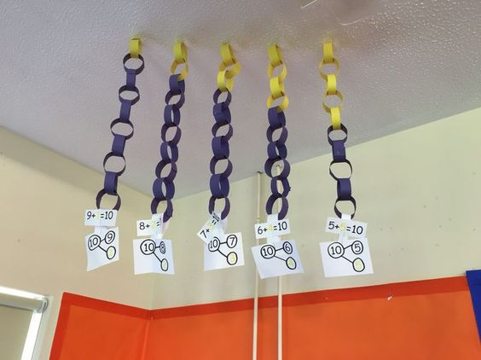

Science
~Tuesday and Friday~
45 Minutes a Day
Video: Weather Magazine
Video: Read Aloud
Goal: We will summarize daily weather conditions noting changes that occur from day to day and throughout the year.
Read: Sunlight  Watch: Be a Weather Watcher  Activity: Weather Observation Recording Sheet  (You can do this all week if you want!)  Example Craft:  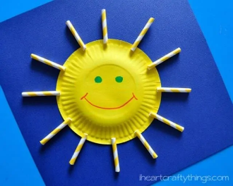  Craft Ideas:  7 Fun Weather Crafts for Kids | Read: Rain  Watch: How Do We Know When It Will Rain?  Activity: Scholastic Learn at Home  (Scroll down to Day 15)  Example Craft:  If you get hungry after making these crafts,try making a yummy weather snack using graham crackers, mini marshmallows, blue icing, and Air Head Extremes. Or try making something else.  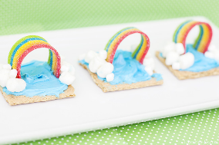

Writing
Include with Science time!
Video 1: Opinion Writing

Goal: Use a combination of drawing, dictating, and writing to compose opinion pieces in which they tell the topic they are writing about and state an opinion or preference about the topic
Weather Opinion Writing Prompt  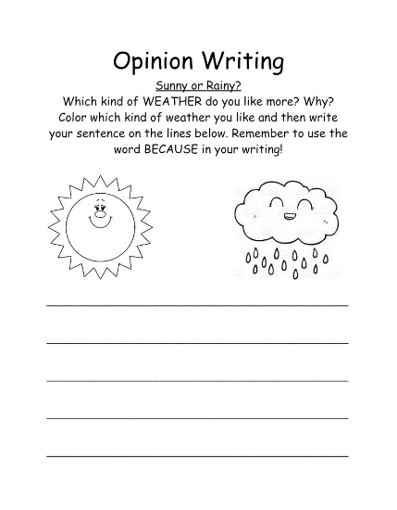 | Writing Paper  Pick one prompt below and write about it!  ~What do you like to do when it rains?  ~What do you like to do when it’s sunny?  ~What do you like to do when it snows?  ~How do you feel when there is a thunderstorm?

Weekly Challenge
STEAM Weather Ideas- Click on an image to be directed to the instructions. Share your experiments with your teacher.
