April 20-April 24

Reading
Raz Kids  Or Read | Raz Kids  Or Read | Raz Kids  Or Read | Raz Kids  Or Read
Read a Story  Book  Draw, tell or write about your favorite part of the story | Read a Story  Book  Talk about what this book made you think about (connections).  Example book:  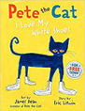  Connections:  One time I stepped in mud and my shoes got all muddy! | Hunt for a Non-fiction  Book  A non-fiction book tells information and gives facts. Non-fiction books teach you something.  See if you can find a non-fiction book in your home or online. | Read a Story  Book  Read your book to someone or something else.  Examples:  Stuffed Animals  Pets  Grandma (on FaceTime)  Siblings

Math
DreamBox | DreamBox | DreamBox | Counting Practice | Problem solving
Measuring:  Longer or shorter  Cut a piece of string or get a paper towel roll or any object to use for measuring. Find four things that are shorter than your object and four things that are longer. Bonus: find two things that are the same size.  Extension:  Draw a picture of your findings: | Find five small objects (cheerios, beads, legos..etc.). Use a cup, bowl or your hand to hide some of the objects. Ask student how many are missing or hidden. Optional: Repeat with six, seven, eight, nine & ten | Play Tens Go Fish with a deck of cards.  -deal five cards each  -put down any pairs that make 10 and replace with cards from the deck  -on each players turn ask for the card that with your card makes 10 if an opponent has it they give it up if he doesn’t have it-Go Fish!  Winner has the most pairs of 10. | Fun counting videos that include things we miss (Grandparents & beaches)  Counting by 1s  https://www.youtube.com/watch?v=cVwjmC-gpBU  Counting by 10s  https://www.youtube.com/watch?v=_yr-IuM4SEA  Counting by 5s  https://www.youtube.com/watch?v=r176jXYwct8 | Problem Solving:  Grab some manipulatives! (jelly beans, legos, goldfish)  Write your own stories or try some of these!  Nathan was playing with 7 cars. Mark was playing with 3 cars. How many cars did they have altogether?  Chase had 10 toys. 4 of the toys were cars. Some of the toys were trucks. How many toys were trucks?

Writing
Pick Three writing prompts a week! Also, remember not to help your child spell the words. They can use the Word List and sound out on their own.

Watch Earth Day Every Day by Lisa Bullard on youtube.com (click on link)  Make a list of 5 ways to help the earth. | Watch Michael Recycle by Ellie Bethel on youtube.com  Write a list of 5 things you can recycle. | Make a sign to show how you can help the earth. | Writing Prompt  I can help the earth by____. Use details in your story. | Write a letter to a friend or family member about how they can help the earth.

Popcorn Words
The word of the week is: choose one or two words from the list that you do not know.
Review all sight words.

Make a flashcard! | Look for it in books.  (Write each letter on a piece of paper-mix them up and then build sight words.) | Write it 10 times. (choose)  Write it fancy, write it neat, bubble write it, write your words with red vowels and blue consonants | Rainbow Write  Write the word in different colors all over the page. | Be creative!  Build it with playdough or cereal, write it with sidewalk chalk

Science
Focus on Earth Day, celebrated April 22nd. Let’s learn about different ways we can help to save the earth!
Listen to this book to learn more!
HOW TO HELP THE EARTH BY THE LORAX by Tish Rabe-Earth Day Book
https://www.youtube.com/watch?v=lbUS3jPjyrc
Mess Free Earth Day Craft. Paint a picture of the earth!  https://www.pinterest.com/pin/697143217299417585/  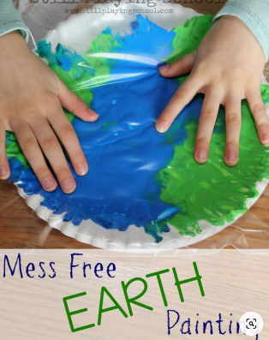 | A messy but fun way to paint a picture of the earth!  https://www.pinterest.com/pin/332773859964626955/  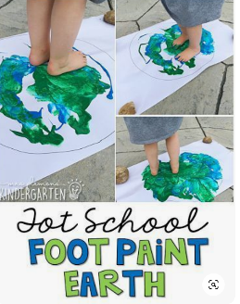 | Earth Day Coloring Pages  https://olphreunion.org/earth-day-coloring-pages/  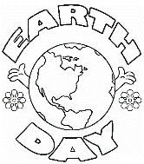 | More earth day painting!  https://thesimpleparent.com/earth-day-craft-preschoolers-will-love/  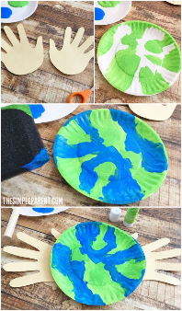 | Make something beautiful out of recycled magazines and pipe cleaners!  https://theresjustonemommy.com/butterfly-craft-from-magazine-pages/#_a5y_p=5069793  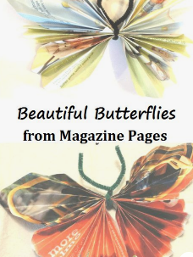
Weekly Challenges

Make recycled crayons with old and broken crayons. Example
https://www.growingajeweledrose.com/2019/05/homemade-crayons.html

Here is a book that your child can construct, color, and read to learn about ways we can help our earth! https://www.teacherspayteachers.com/FreeDownload/Earth-Day-Emergent-Reader-for-Preschool-Pre-K-and-Kindergarten-FREE-1685630

