March 30-April 3

Reading
Raz Kids  Or Read | Raz Kids  Or Read | Raz Kids  Or Read | Read a Story  Book  Discuss: Your favorite part or what part you would change.
Read a Story  Book  Discuss: The setting and characters in the book.  Act out the story. | Read a Story  Book  Discuss: The problem and solution in the book. | Read a Story  Book  Discuss: Any unfamiliar words and find sight words through it. | Read a Story  Book  Discuss: How the feelings change in the book.

Math
DreamBox | DreamBox | DreamBox
Make combinations of 5, 6, 7, or 8 using cereal (or something you have in the house). Ex: 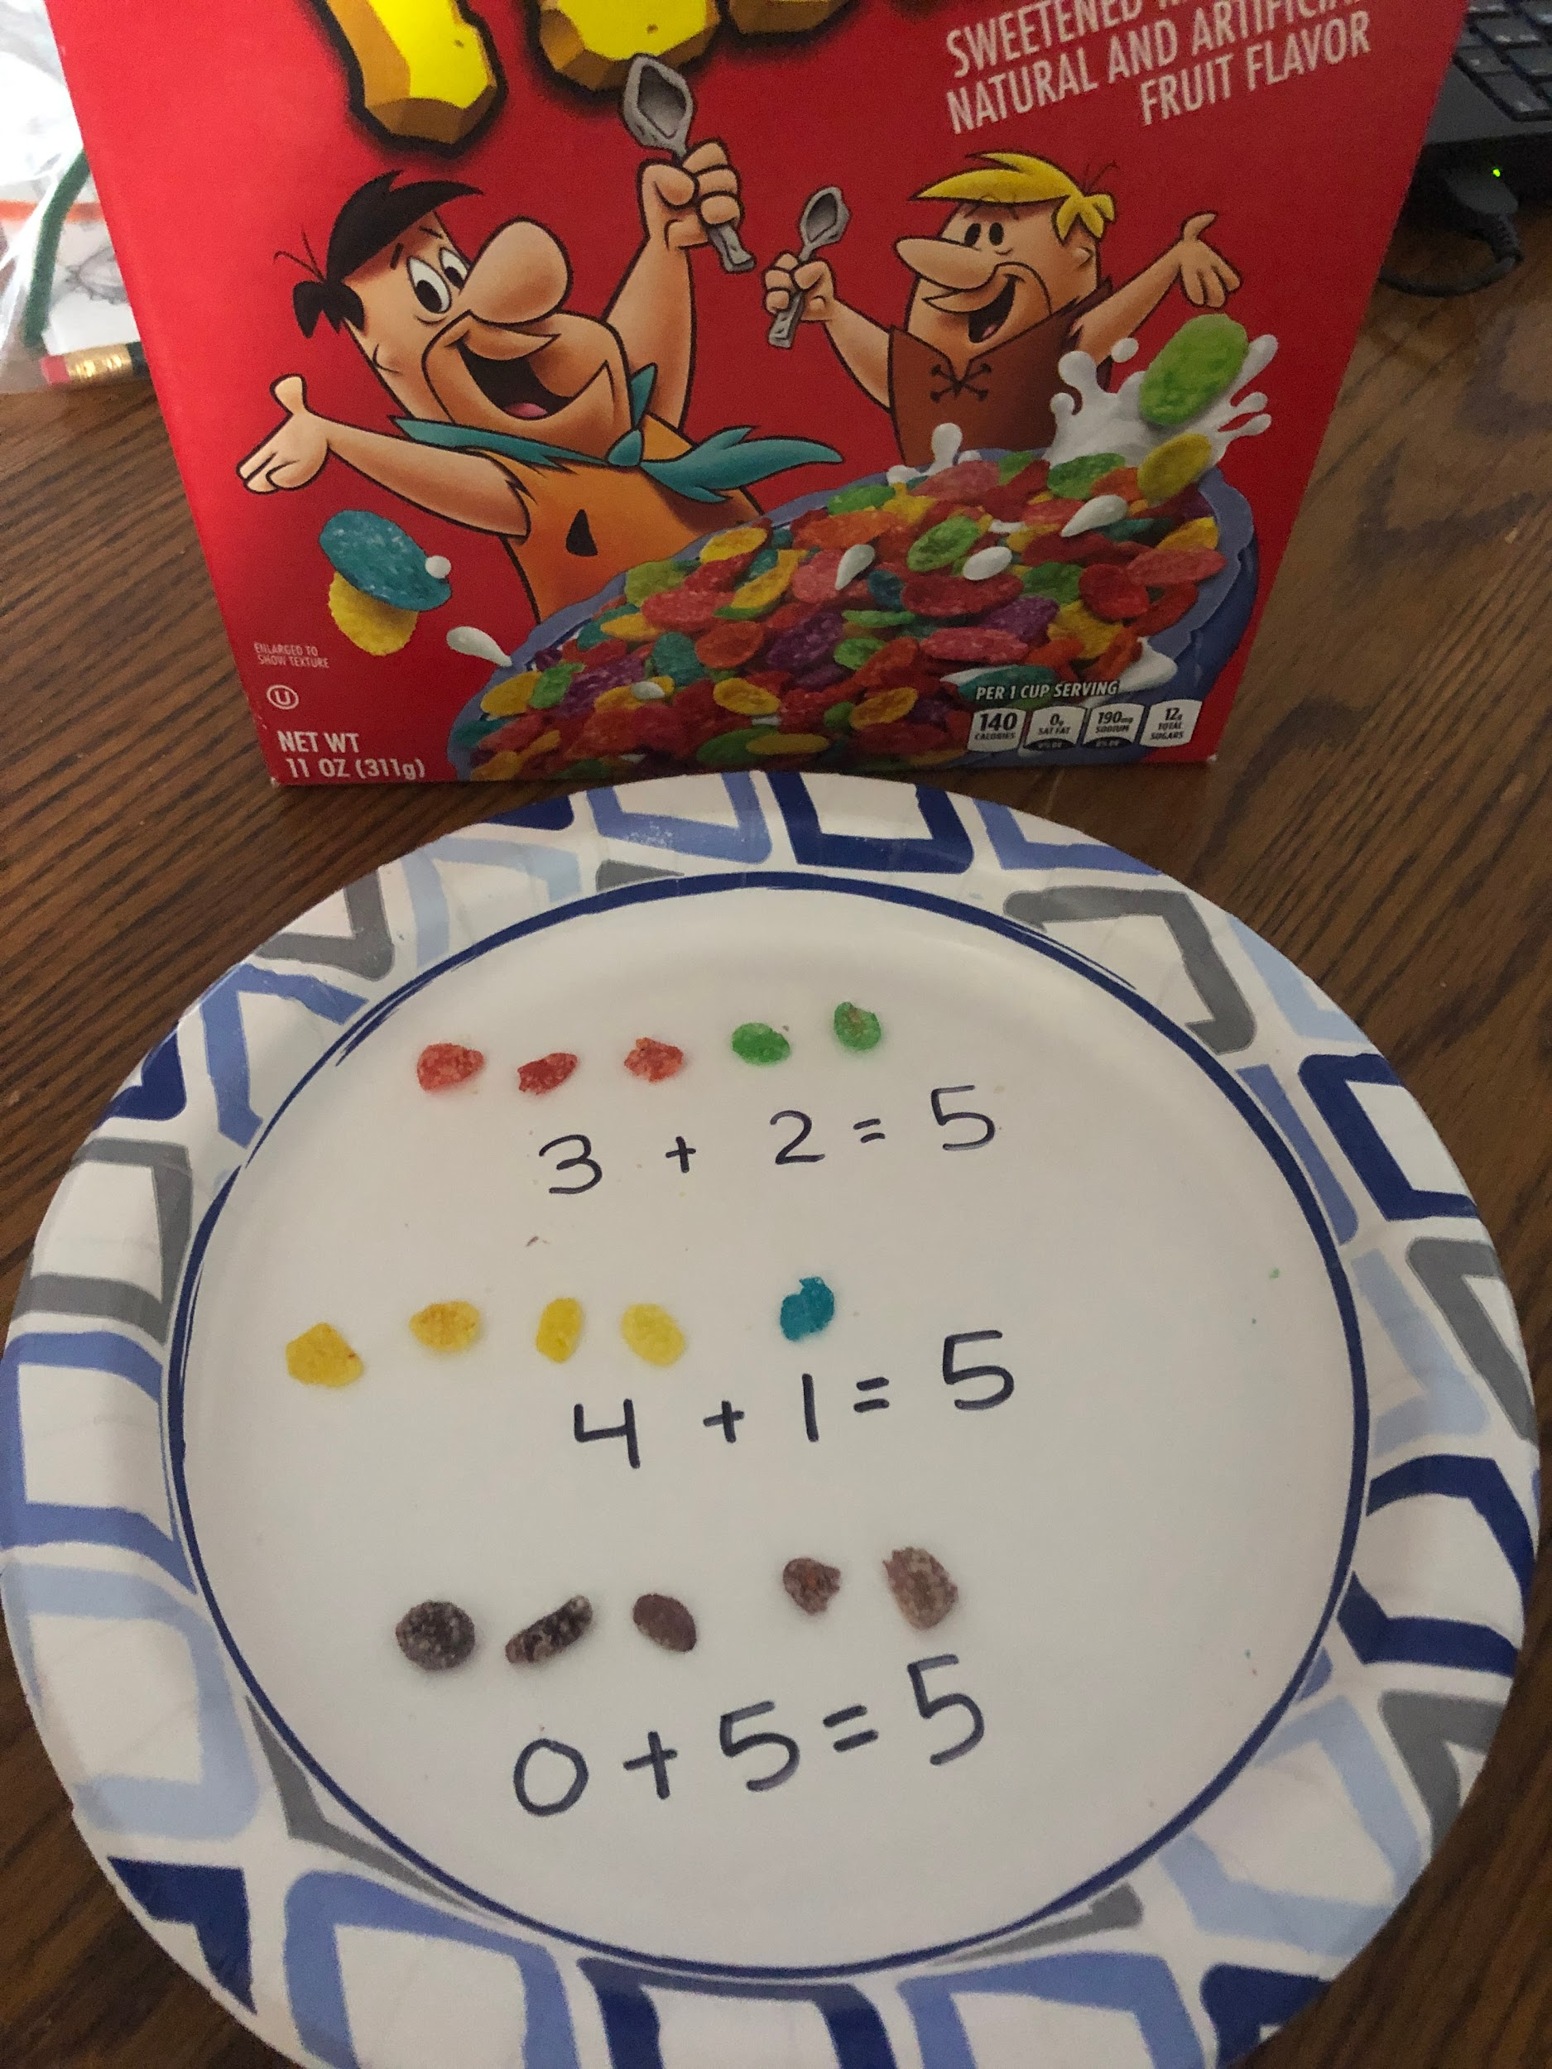 | Review 2-D shapes with things around the house. Draw (or print off pictures) of 2-D shapes and use your imagination to find things that match the 2-D shape. Be sure to tell the attributes of each shape. Ex: It has four points and corners, it has no sides. | With a deck of cards, play more or less.  Pick what the goal is..More  Each player puts one card down and whoever gets the bigger number takes the cards, Then switch the goal to less. | Write your numbers as high as you can go...make sure the numbers are not backwards.  -You can use fun YouTube videos to help you count and move,  Youtube- Jack Hartman count to 100. | Problem solving:  You can do this during snack time! Get your child’s favorite snack (goldfish, pretzels, grapes, etc) and come up with subtraction problems. Have your child act them out with a snack. Ex: “If you have 8 goldfish and you eat 3, how many do you have now?”

Writing
Pick Three writing prompts a week! Also, remember not to help your child spell the words. They can use the Word List and sound out on their own.
If you were a superhero what would be your superpower? | What is your favorite movie and why? Tell the characters and setting. | What is your favorite dinner? Why? Use describing words. | What do your favorite shoes look like? Draw a picture of them and use describing words to tell about them. | Would you like to learn at school or at home better? Why?

Popcorn Words
The word of the week is: choose one or two words from the list that you do not know.
Review all sight words.

Make a flashcard! | Look for it in books.  (Write each letter on a piece of paper-mix them up and then build sight words.) | Write it 10 times. (choose)  Write it fancy, write it neat, bubble write it, write your words with red vowels and blue consonants | Rainbow Write  Write the word in different colors all over the page. | Be creative!  Build it with playdough.

Science
Oviparous animals- animals that are born from an egg!
What comes from an egg video? (click on this link to watch and introduce) | https://classroommagazines.scholastic.com/support/learnathome/grades-prek-k-week-2.html  Click on the link and scroll down to day 10. | Create a life cycle of a chicken. You can just draw these, or do some fancy work like this picture:  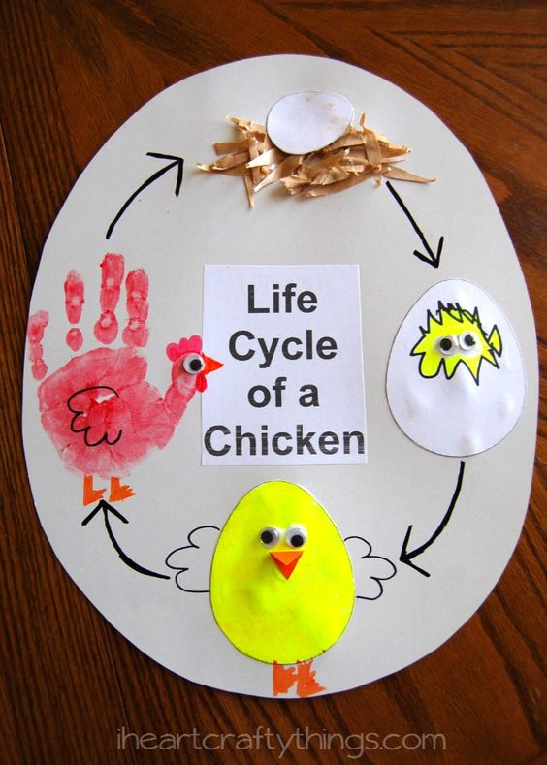 | With your Khan Academy Kids app (free APP on iPad only; and no ads)- look to your library and scroll down to NATIONAL GEOGRAPHIC YOUNG EXPLORER - choose the book Looking At Eggs | Make a list of Oviparous animals (with pictures) on one peice of paper and then a list of not oviparous animals on the other side (with pictures) EX:  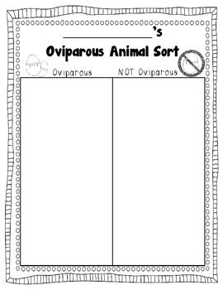

Weekly Challenges

1. Make breakfast, lunch, or dinner with your parents.
2. Help your parents with one chore arounds the house.

Cultural Review

https://digital.emagazines.com/TIME_for_Kids_K/20191206/index.html?t=6917c5ca-a679-414e-8e76-d0d6a1bb7484

