April 6th - April 8th
Reading

Monday | Tuesday | Wednesday
Raz Kids or Read | Raz Kids or Read | Raz Kids or Read
Read a Story  Book  Draw a picture of the characters. | Read a Story  Book  Talk about the problem/solution.  Talk about your favorite part. | Read a Story  Book:  After reading, retell the story. (beginning/middle/end)

Writing
This week’s lessons will be about the following story (click on the link to hear Peter Rabbit --please supervise as they watch on youtube!). If you are unable to access video you can still complete these writing activities!

Peter Rabbit
https://www.youtube.com/watch?v=EuTlQCGxE5Y&feature=youtu.be

Monday | Tuesday | Wednesday
Watch Peter Rabbit. Make a list of things you would find in a garden and what you would not find in a garden.  In a garden I would find... In a garden I would NOT find... | Write a letter to Peter Rabbit. Offer him ideas about what he should have done instead of going into the garden or tell him why he should not have gone in the garden.  OR  Make a card for a family member and mail it! | What is your favorite animal and why?  Remember to:  --use capital letters correctly  --finger space  --use punctuation  --spell popcorn words correctly  --reread your work and EDIT  Then draw a picture to match!  I cannot wait to see it!

Math/Social Studies
This week’s lessons will be about the following story (click on the link to hear Peter Rabbit --please supervise as they watch on youtube!). If you are unable to access video you can still complete these activities!

Peter Rabbit
https://www.youtube.com/watch?v=EuTlQCGxE5Y&feature=youtu.be

Monday | Tuesday | Wednesday
DreamBox | DreamBox | DreamBox
We have learned about maps! Make a map for Peter Rabbit of your backyard! (If you do not have a backyard just pretend!)  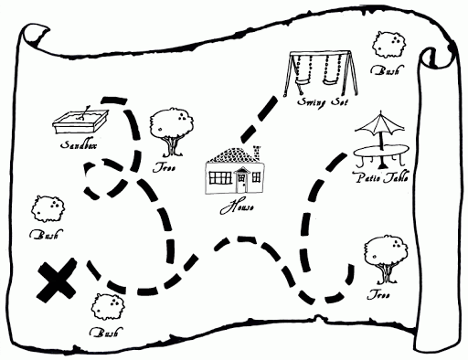 | Pretend you are a rabbit! If you snuck into your backyard what would you do? Pick a safe starting point and act it out!  (Example: I would go under the slide, around the trampoline, over the flowers, up and down the stairs and across the yard to safety!!) | Problem Solving:  Grab some manipulatives! (plastic eggs/cotton balls (rabbit tails)/  stuffed animals/blocks)  Write your own stories or try some of these!  Peter found 12 carrots. He ate 4 of them. How many carrots does he have left?  There were 8 cucumbers and 7 watermelons in the garden. How many things were in the garden altogether?  I saw 10 rabbits in the garden. Some were brown and some were white. How many of each could there be?

Word Study

Monday | Tuesday | Wednesday
Parent Involved: Put popcorn words on small pieces of paper and spread out on the floor. Call out a word and have your child hop from word to word reading and spelling them!!  OR  Independent Activity: Have your child write their words with a white crayon and then color over them with a marker to “reveal.” | How does a rabbit move? It hops! What other  ~op  words can you make?  (bop, cop, mop, pop,top…)  Can you illustrate any of the words? | Write the alphabet correctly and neatly. Write both capital and lowercase letters in order. Use crayons or markers to make it snazzy!  Ex: Aa Bb Cc Dd Ee ….  Make sure tall letters are tall and small letters are small! Watch for reversals!

Science

Monday | Tuesday | Wednesday
Click the link to learn about rabbits!  Rabbits  What was your favorite page? I liked page 11...it made me think about how beavers also gnaw on things to keep their teeth short! | Read the book again. Write two fun facts you learned about rabbits.  How do rabbits exercise? Can you exercise like a rabbit?  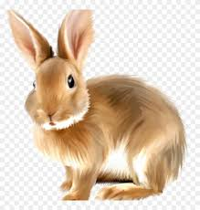 | Craft time! Create a bunny! Here are some ideas to get you started! Share your finished project with me!  